${QR}

Attention to: ﻣﺆﺳﺴﺔ احمد غطاس ﻟﻠﻤﻘﺎﻭﻻﺕ

IDI PR #: 100004
Established by: Gamal Saad

TIS Visit

Inspection Report - Soil Improvement

Date of visit: 26-Jan-2025

Location: 24.6722137,46.7283119

( Inspection Department, Saudi Arabia)

Owner | مصطفى سامي | TIS Company | CPV Arabia
Contractor | ﻣﺆﺳﺴﺔ احمد غطاس ﻟﻠﻤﻘﺎﻭﻻﺕ | Report Issue Date
Project Location | 24.718106169467518,46.8131461331344 | Inspection # | 9
Inspection Stage | Soil Improvement | No. Of buildings | 1
Inspector Name | Gamal Saad | Work in progress | Soil Improvement( )
Email | GSAAD@CPVARABIA.COM | Telephone | 0591007296

Inspection Results: Satisfactory
Description of the inspections carried out:

CPV ARABIA has conducted an on-site technical inspection (IDI) for Project PR #100004 during the pre-pouring phase of the Soil Improvement.

The details of the inspection are described further as we go through this report.
Summary

Risks Assessment:
- High Risk, Major stability issue that can affect the building’s stability
Soil Report, Construction Plans and Saudi Building Code have to be followed
Stages missed without TIS involvement:
- The project has a missing stage as shown in the attached image - The project has a missing stage as shown in the attached image - The project has a missing stage as shown in the attached image - The project has a missing stage as shown in the attached image - The project has a missing stage as shown in the attached image - The project has a missing stage as shown in the attached image - The project has a missing stage as shown in the attached image
Interpretation of Additional Visit:
- Not exist

General Site Pictures and Construction Plans
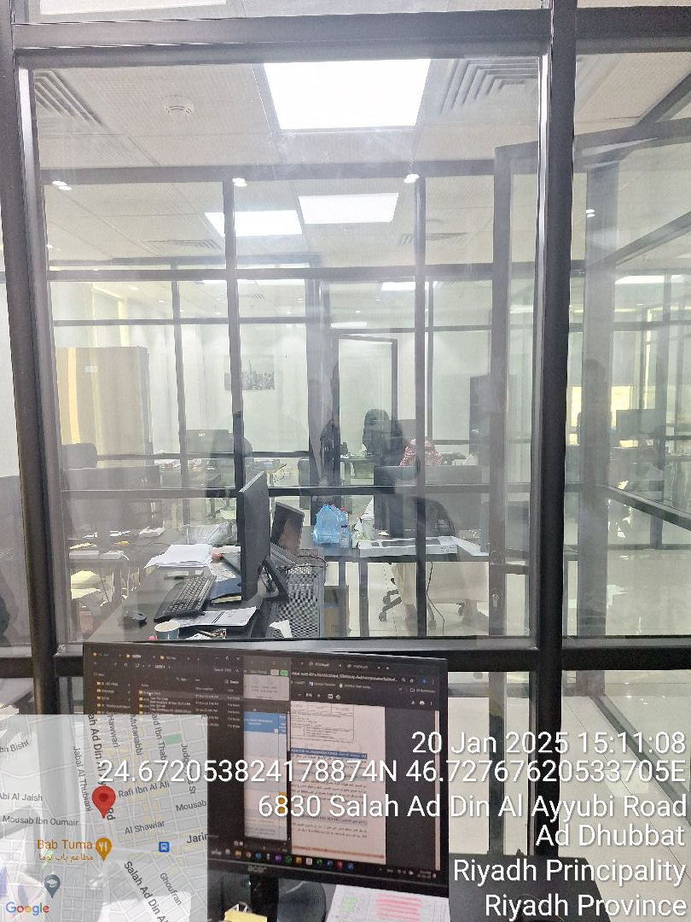
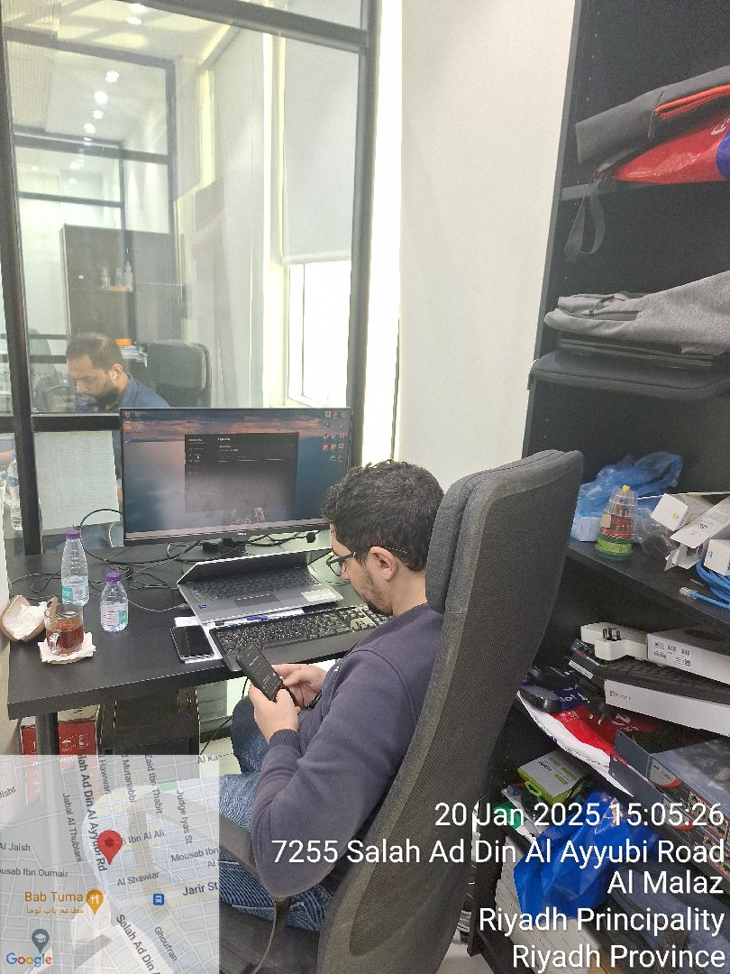

General site picture and construction plans

Checklist

No | Checklist | SBC Reference | Result | Remarks
1 | Inspection criteria
1.1 | Is the site ready for inspection with safe inspection conditions and safe access for the TIS inspection? | - | Passed
1.2 | Were there any modifications in the project that is different from the RD0, Soil Report and Construction Plans...etc.)? | - | Passed
1.3 | Is there any missing inspection stages in the project? | - | Passed
1.4 | Are there any defects observed that can affect the building’s stability or RD5 inspection for slab stage hasn’t been closed yet? |  | Passed
1.5 | Is the laboratory conducting tests certified by an ISO/17025-accredited body? | - | NA
2 | Checklist
2.1 | Are there any visible signs of inadequate compaction, such as surface irregularities or material segregation? | - | Passed
2.2 | Are the area cleared of debris, vegetation, and loose soil? | - | Passed
2.3 | Does the soil classification report been provided and Soil type match the approved specifications? | - | Passed
2.4 | Are The compaction layer is uniform, and thickness matches with SBC specifications.? | - | Passed
2.5 | Do the Compaction equipment and methodology comply with the approved method statement? | - | Passed
2.6 | Does the moisture content of the soil match the optimum moisture content (OMC) as per the provided proctor test/modified proctor test results? | - | Passed
2.7 | are the Field dry density measured using approved methods (e.g., sand cone, nuclear gauge) as per test specifications? | - | Passed
2.8 | Are the compaction test results (Field compaction percentage) satisfactory and comply with SBC? | - | Passed
2.9 | Is the test area level, debris-free, and prepared according to the approved method statement? | - | Passed
2.10 | Are the load is applied incrementally as per approved standards (e.g., ASTM D1196)? | - | Passed
2.11 | Are The load-settlement relationship matches design requirements for bearing capacity and settlement limits? | - | Passed
2.12 | Is a detailed test report, including load-settlement curves and results provided? | - | Passed
2.13 | Are the compaction test results for the previous layers provided and verified on site? | - | Passed
2.14 | Does the test plate meet the specified dimensions and thickness? | - | Passed

Risk Assessment

${RAPage}
${BTicketImag}

${Description}
${Passed}

Engineer In Charge of Inspection | Area Manager | Technical Inspection Manager
Name: Gamal Saad | Name: | Name:
Signature:  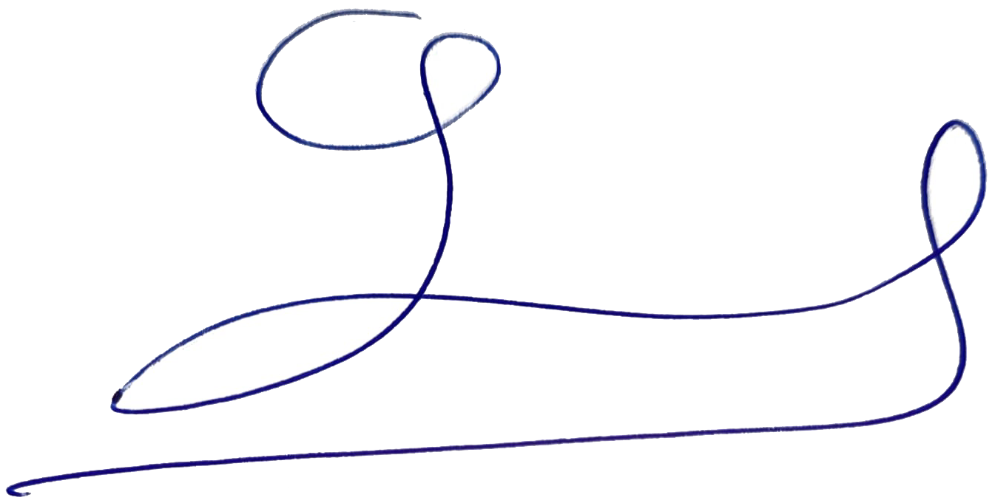 | Signature: | Signature:
Date of Issuing the report:

