${QR}

Attention to: ﻣﺆﺳﺴﺔ ﻏﻴﺜﻪ ﻋﻄﻴﻮﻱ ﻣﺒﺮﻭﻙ ﺍﻟﻤﺤﻤﺪﻱ ﻟﻠﺘﺸﻐﻴﻞ ﻭﺍﻟﺼﻴﺎﻧﺔ

IDI PR #: 100100
Established by: Islam Reyad

TIS Visit

Inspection Report - Retaining walls

Date of visit: 27-Jan-2025

Location: 24.6721962,46.7283278

( Special Projects, Saudi Arabia)

Owner | ﻋﺒﺪﺍﻟﻠﻪ ﻏﺎﺯﻱ ﺑﻦ ﺧﻀﺮ ﺳﺒﻴﻪ | TIS Company | CPV Arabia
Contractor | ﻣﺆﺳﺴﺔ ﻏﻴﺜﻪ ﻋﻄﻴﻮﻱ ﻣﺒﺮﻭﻙ ﺍﻟﻤﺤﻤﺪﻱ ﻟﻠﺘﺸﻐﻴﻞ ﻭﺍﻟﺼﻴﺎﻧﺔ | Report Issue Date
Project Location | ﺍﻟﻤﺪﻳﻨﺔ ﺍﻟﻤﻨﻮﺭﺓ - ﺍﻟﻌﻮﺍﻟﻲ | Inspection # | 16
Inspection Stage | Retaining walls | No. Of buildings | 1
Inspector Name | Islam Reyad | Work in progress | Retaining walls ( )
Email | IReyad@cpvarabia.com | Telephone | 581097785

Inspection Results: Additional Vsit
Description of the inspections carried out:

CPV ARABIA has conducted an on-site technical inspection (IDI) for Project PR #100100 during the pre-pouring phase of the Retaining walls .

The details of the inspection are described further as we go through this report.
Summary

Risks Assessment:
- There are difference between the executed drawing and the RD0 drawings. - The plate diameter and thickness as per test specifications hdfffffffffffffffff- The excavation level not complying with soil report recommendations and SBC limits, high risk, Major impact on the building stability which will increase the possibility of differential settlement of the building and affect the durability of the foundations The level of excavation should comply with soil report and saudi building code- bngnb c cvb vcxb- High Risk, Major stability issue that can affect the building’s stability Construction Plans and Saudi Building Code have to be followed
Stages missed without TIS involvement:
- During the ongoing project, we have identified that the contractor cast concrete before the TIS visit, which poses a potential risk to the projects quality. To address this issue, we will need to conduct on-site testing to confirm that the works have been executed based on SBC and engineering principles.- The project has a missing stage as shown in the attached image
Interpretation of Additional Visit:
- The executed works on site are not in accordance with the plans or project documents received from the client, the client must upload the updated plans or project documents to the MALATH portal. This will enable us to compare the updated plans with the executed works on site and identify the risks on the buildings based on updated documents.

General Site Pictures and Construction Plans
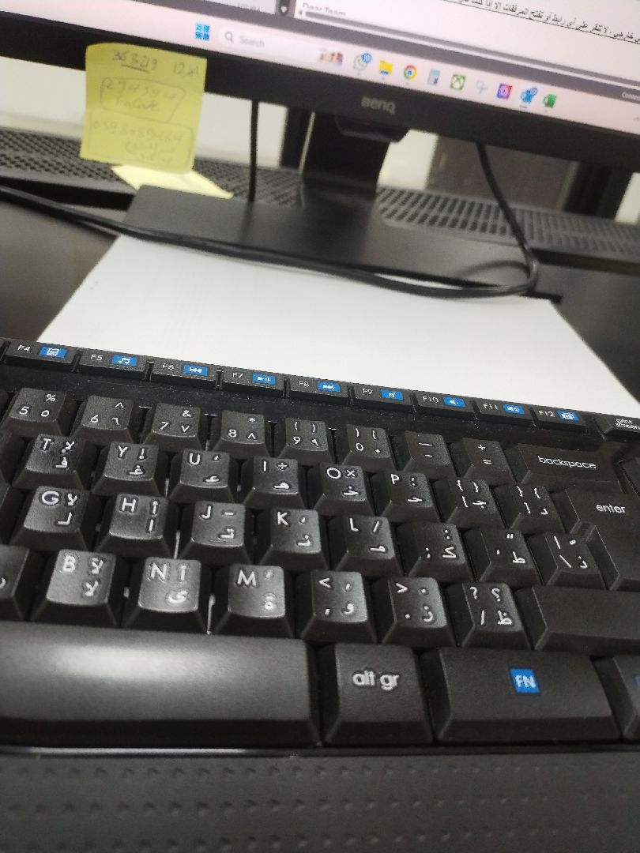
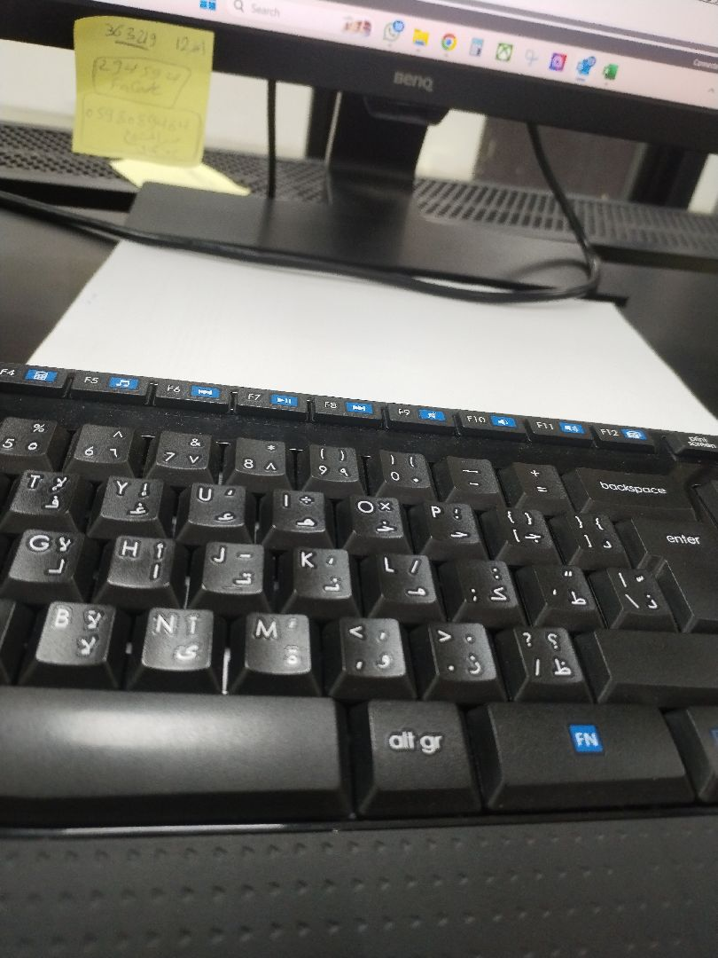

General site picture and construction plans

Checklist

No | Checklist | SBC Reference | Result | Remarks
1 | Inspection criteria
1.1 | Is the site ready for inspection with safe inspection conditions and safe access for the TIS inspection? | - | Passed
1.2 | Were there any modifications in the project that is different from the RD0, Soil Report and Construction Plans...etc.)? | - | Not Passed
1.3 | Is there any missing inspection stages in the project? | - | Passed
1.4 | Are there any defects observed that can affect the building’s stability or RD5 inspection for slab stage hasn’t been closed yet? |  | Passed
1.5 | Has the client provided verified concrete compressive strength test results? |  | Passed
1.6 | Is the laboratory conducting tests certified by an ISO/17025-accredited body? | - | Passed
2 | Formwork
2.1 | Are the forms clean and ready for pouring concrete? | - | Passed
2.2 | Is the formwork assembly stable due to the different loads? | - | Passed
2.3 | Were Concrete covers maintained as per approved drawings? | - | Passed
3 | Steel Reinforcement
3.1 | Are the longitudinal reinforcement diameter and number executed as per the construction drawing? | - | Passed
3.2 | Was the Water-stop installed as per the drawings? | - | Passed
3.3 | Is the length of splices according to the SBC specifications? | - | Passed
3.4 | Is the anchorage length of steel reinforcement at the corners of the retaining walls according to the SBC specifications? | - | Passed
3.5 | Is the steel reinforcement free from rust, oil, and contaminants? | - | Passed
3.6 | Are the tie wires installed as required? | - | Passed
3.7 | Are the bends bars within the radius and tolerance uniformly made? | - | Passed
3.8 | Is the thickness of the Retaining walls complying with the construction plans? | - | Passed
3.9 | Do the diameter, quantity, direction, and spacing of the additional longitudinal reinforcement at intersections, openings, and corners comply with the plans? | - | Passed
3.10 | Are the pipe sleeves installed as per engineering principles? | - | Passed
3.11 | Are the horizontal reinforcement diameter and number executed as per the construction drawing? | - | Passed

Risk Assessment

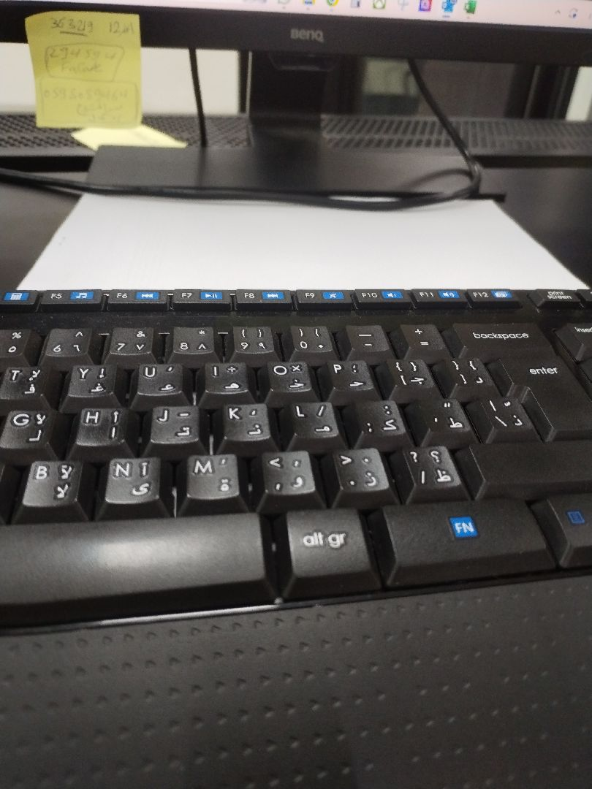

The executed works on site are not in accordance with the plans or project documents received from the client, the client must upload the updated plans or project documents to the MALATH portal. This will enable us to compare the updated plans with the executed works on site and identify the risks on the buildings based on updated documents.
Not Passed
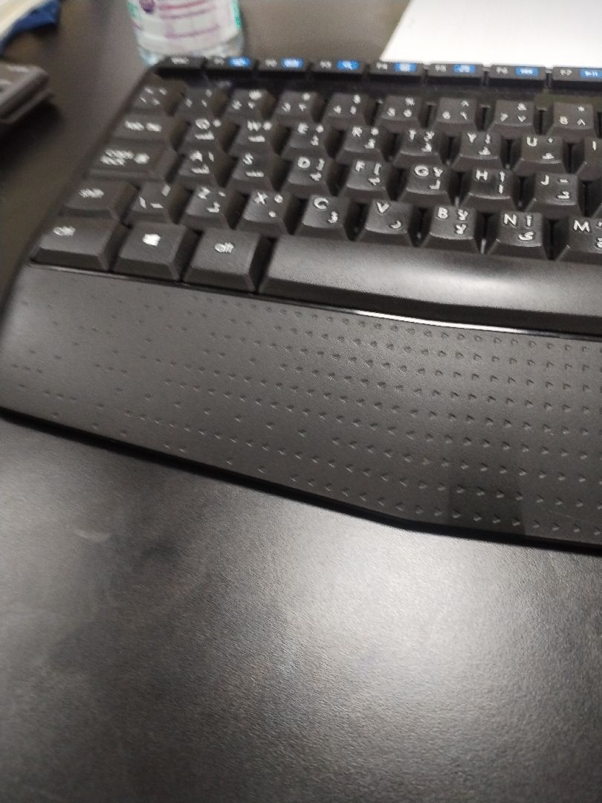

the horizontal reinforcement diameter and number are executed as per the construction drawing
Passed
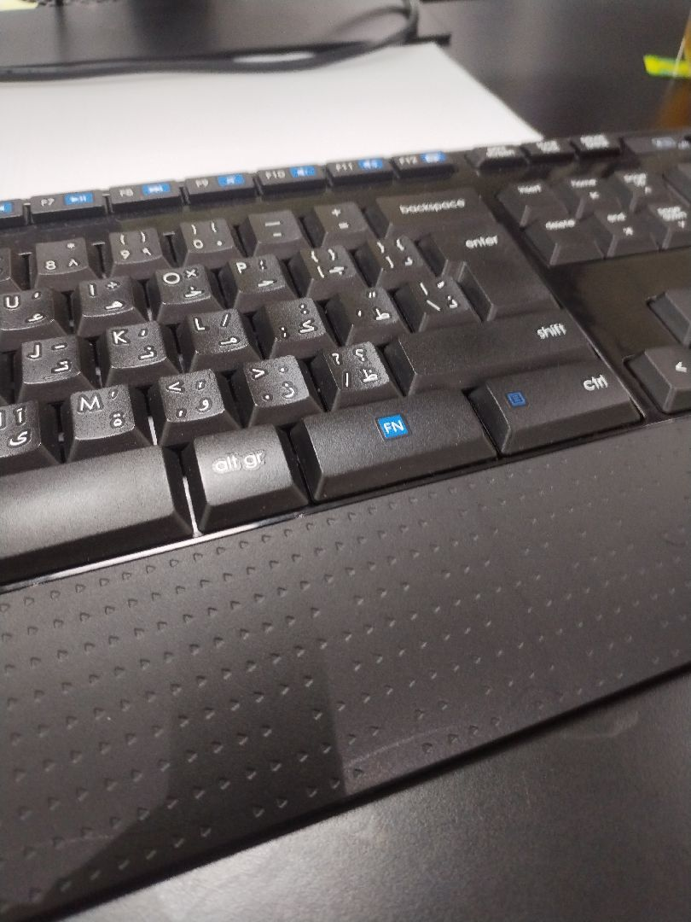

Additional steel reinforcement comply with construction plans
Passed
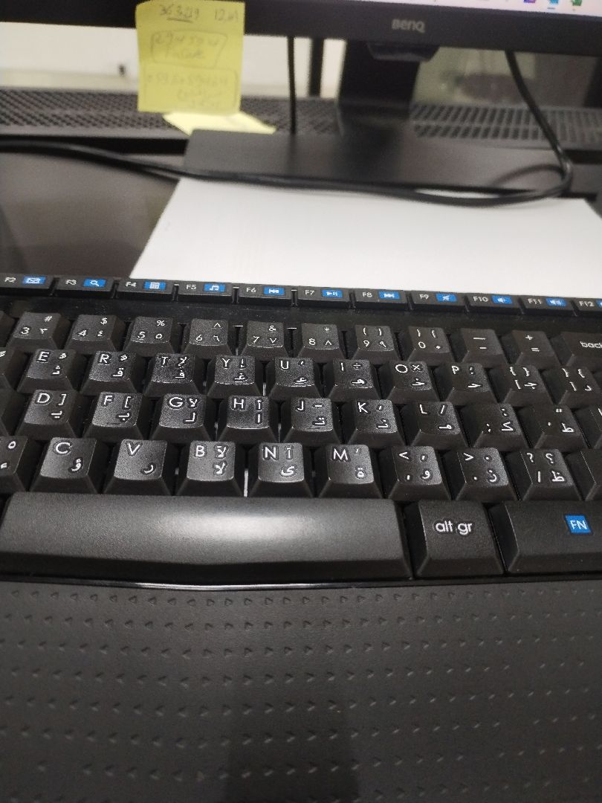

Retaining wall thickness
Passed
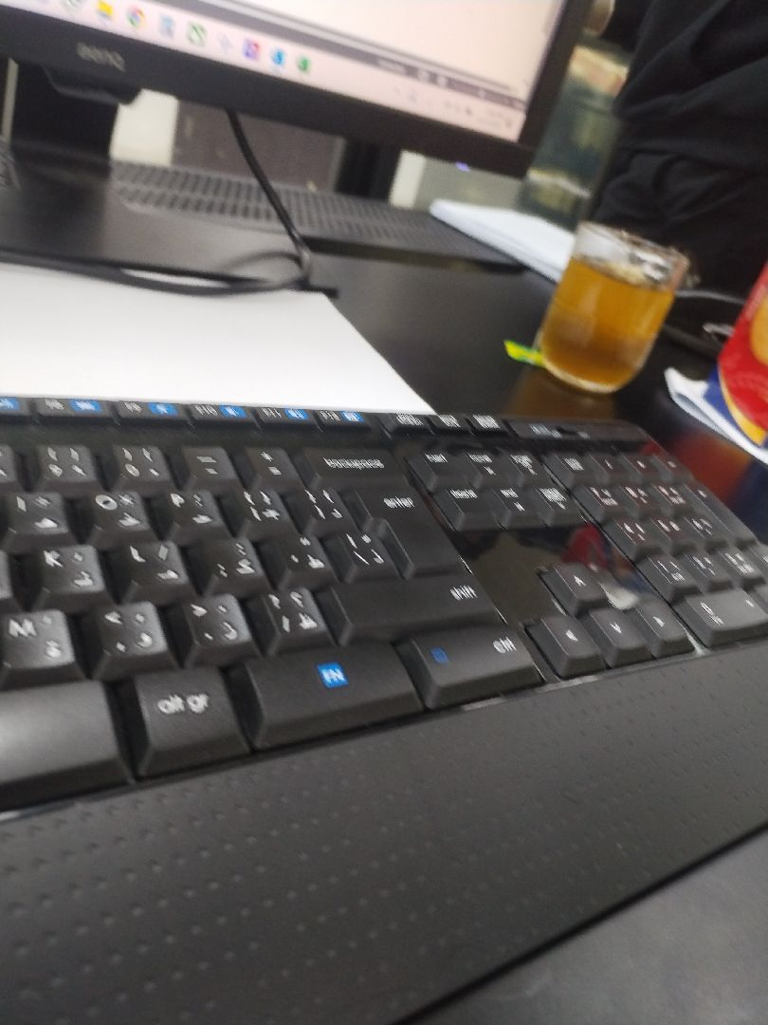

Bent bars
Passed
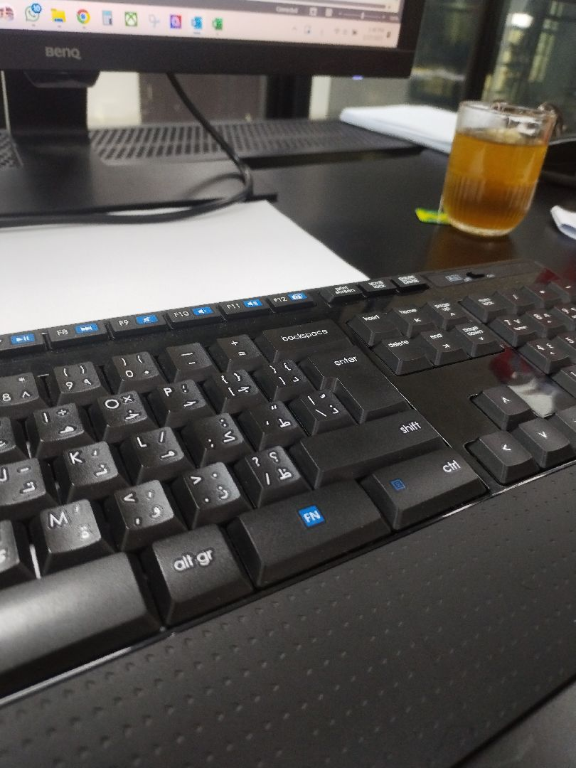

The Anchorage length of the retaining walls steel reinforcement at corners
Passed
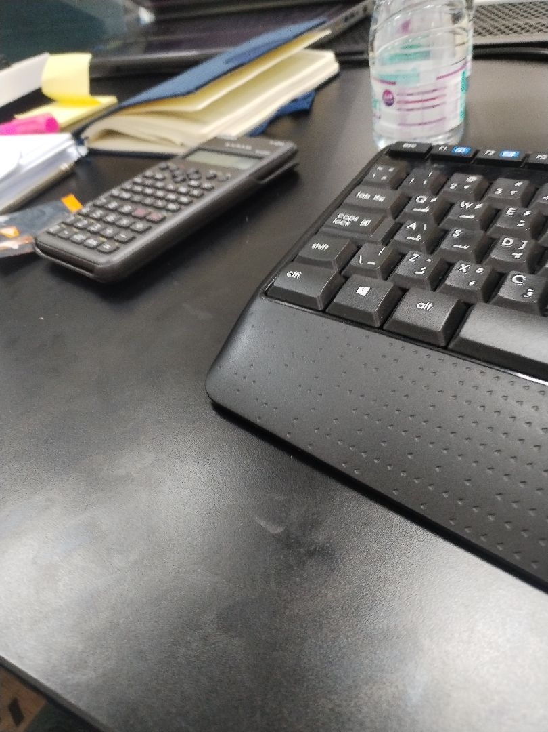

The splice length
Passed
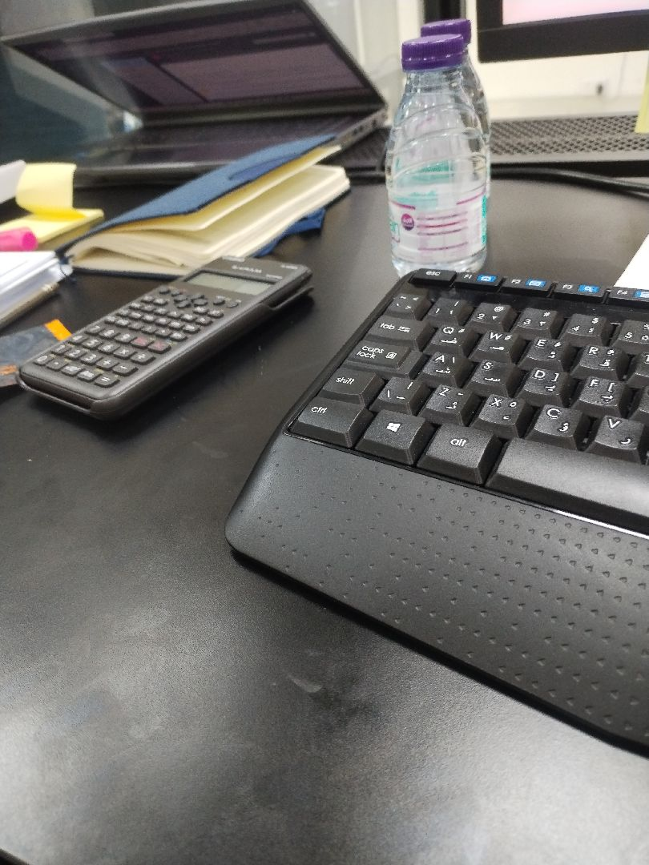

Was the Water-stop installed as per the drawings?
Passed
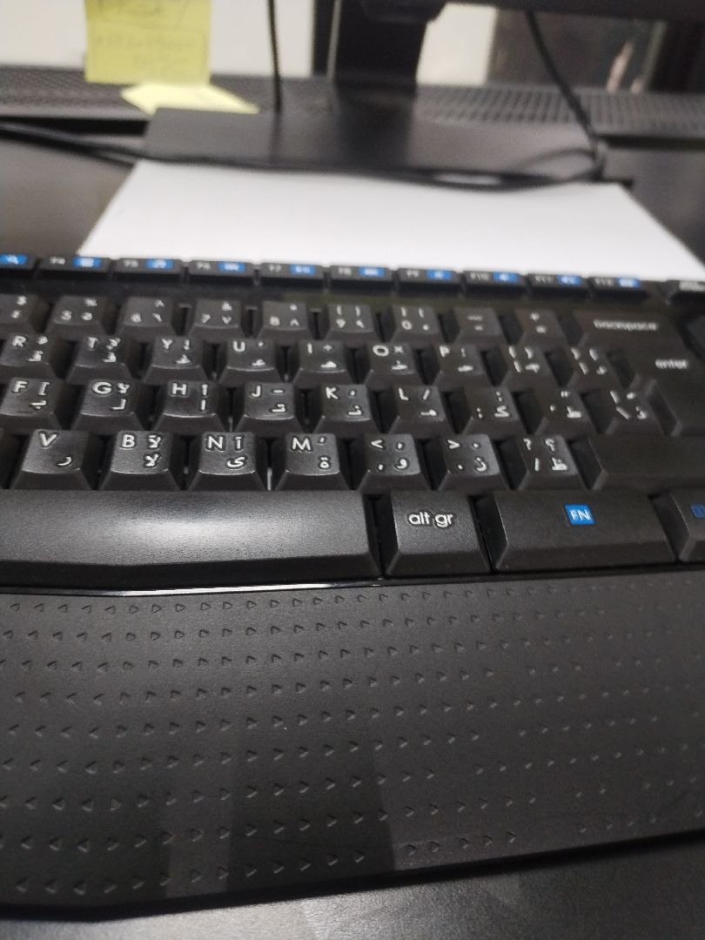

the longitudinal reinforcement diameter and number are executed as per the construction drawing
Passed
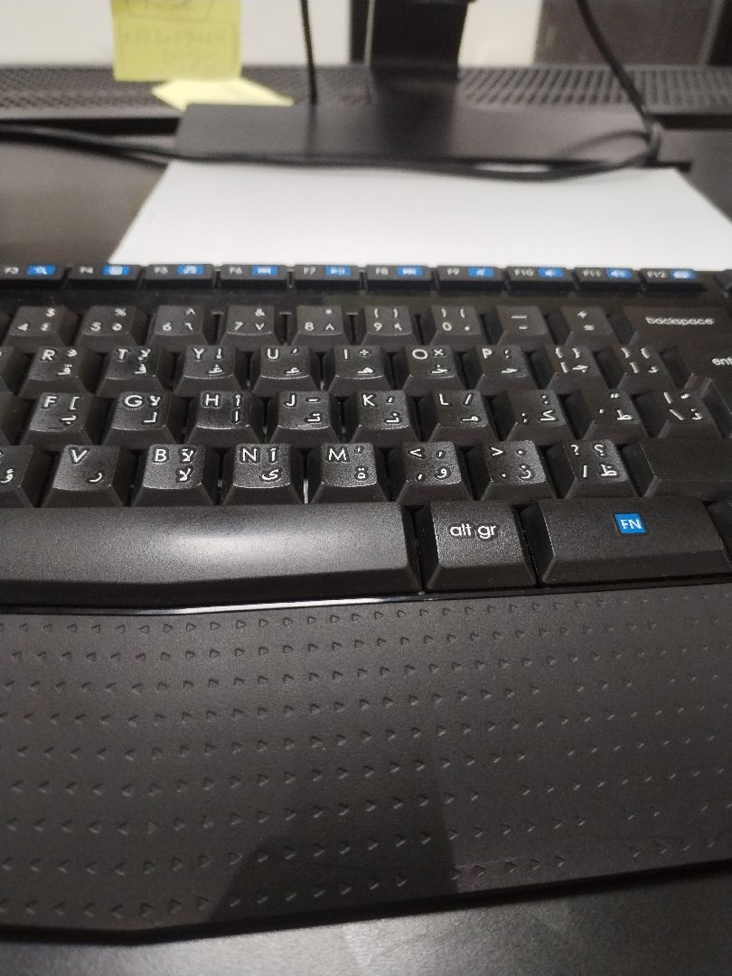

Concrete Cover
Passed

Engineer In Charge of Inspection | Area Manager | Technical Inspection Manager
Name: Islam Reyad | Name: | Name:
Signature:  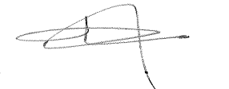 | Signature: | Signature:
Date of Issuing the report:

