${QR}

Attention to: ﺷﺮﻛﺔ ﻣﻴﻌﺎﺩ ﻟﻠﺘﺠﺎﺭﺓ ﻭﺍﻟﻤﻘﺎﻭﻻﺕ

IDI PR #: 127512
Established by: Mohamed Eldapess

TIS Visit

Inspection Report - Waterproofing Envelope Assessment

Date of visit: 19-Feb-2025

Location: 24.6722342,46.7282947

( North Riyadh, Saudi Arabia)

Owner | ﺷﺮﻛﺔ ﺭﺍﻳﺘﻨﺎ ﺍﻟﻌﻘﺎﺭﻳﺔ | TIS Company | CPV Arabia
Contractor | ﺷﺮﻛﺔ ﻣﻴﻌﺎﺩ ﻟﻠﺘﺠﺎﺭﺓ ﻭﺍﻟﻤﻘﺎﻭﻻﺕ | Report Issue Date
Project Location | ﺣﻲ ﺑﺪﺭ | Inspection # | 1
Inspection Stage | Waterproofing Envelope Assessment | No. Of buildings | 1
Inspector Name | Mohamed Eldapess | Work in progress | Waterproofing Envelope Assessment
Email | meldapess@cpvarabia.com | Telephone | 581082681

Inspection Results: Additional Vsit
Description of the inspections carried out:

CPV ARABIA has conducted an on-site technical inspection (IDI) for Project PR #127512 during the pre-pouring phase of the Waterproofing Envelope Assessment.

The details of the inspection are described further as we go through this report.
Summary

Risks may affect the building stability and stop the work (To be resolved by sending the required documents):
- Not exist
Stages missed without TIS involvement (To be resolved by performing the required tests for the missed elements):
- Not exist
Interpretation of Additional Visit:
- There are major defects in the roof waterproofing- The site is not yet ready for inspection. We will reschedule an additional inspection visit for a later date once the site is ready for inspection- There are major defects in the roof waterproofing
Technical Reservations (To be closed by providing the required certificates and reports before the final visit):
- Not exist
Note:
- Not exist

General Site Pictures and Construction Plans


General site picture and construction plans

Risk Assessment



The site is not yet ready for inspection. We will reschedule an additional inspection visit for a later date once the site is ready for inspection
Not Passed
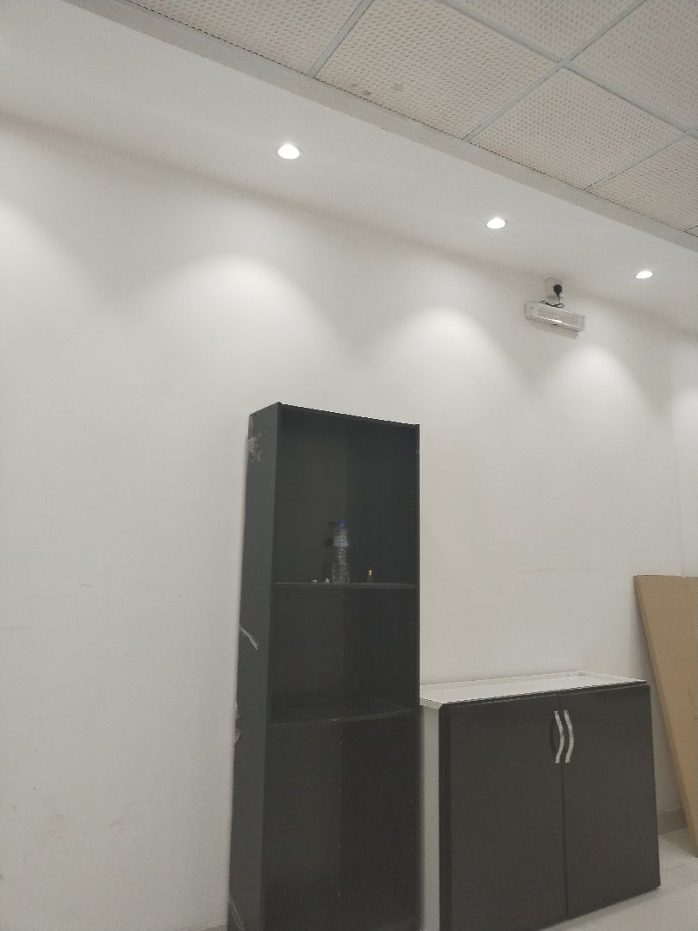

The site is not yet ready for inspection. We will reschedule an additional inspection visit for a later date once the site is ready for inspection
Not Passed
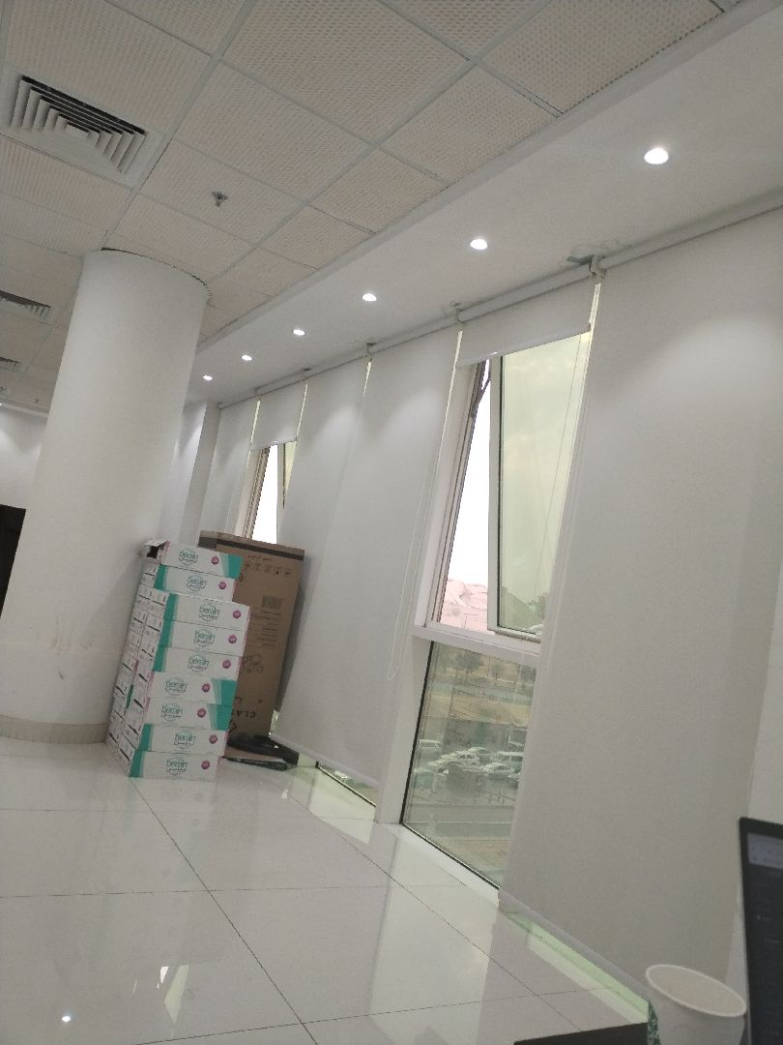

There are major defects in the roof waterproofing
Not Passed
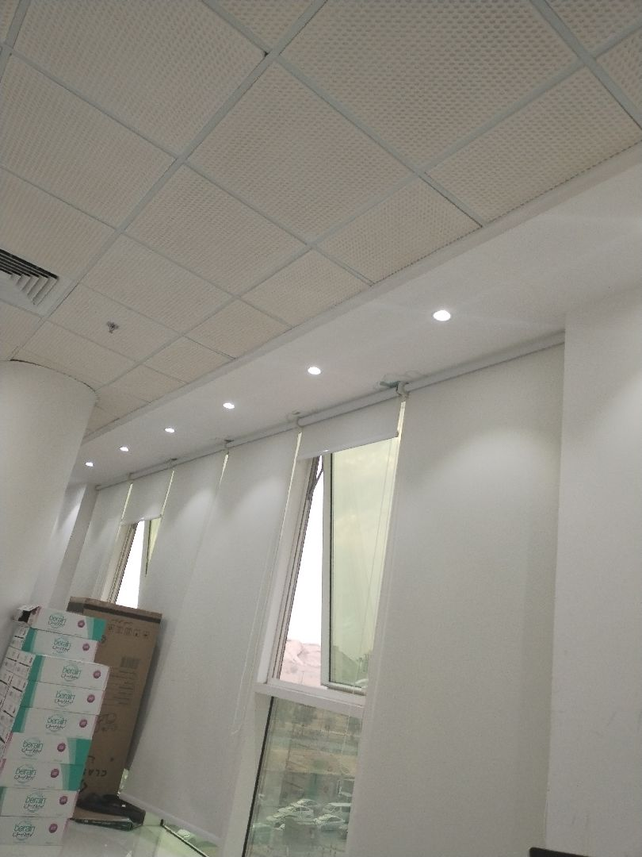

There are major defects in the roof waterproofing
Not Passed

Engineer In Charge of Inspection | Area Manager | Technical Inspection Manager
Name: Mohamed Eldapess | Name: | Name:
Signature:  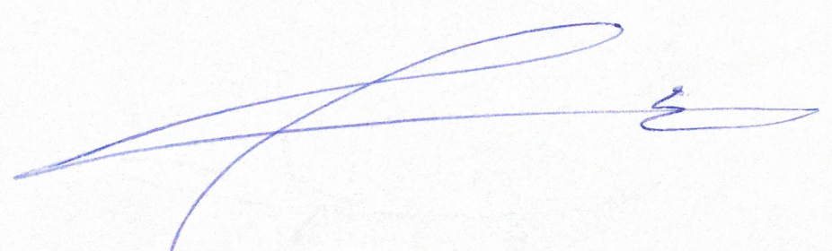 | Signature: | Signature:
Date of Issuing the report:

