${QR}

Attention to: ﻣﺆﺳﺴﺔ ﻓﻼﺡ ﺧﺎﻟﻒ ﻋﺒﺪﺍﻟﻠﻪ ﺍﻟﺸﻤﺮﻱ ﻟﻠﻤﻘﺎﻭﻻﺕ

IDI PR #: 127518
Established by: Ahmed El Saeed

TIS Visit

Inspection Report - Waterproofing Envelope Assessment

Date of visit: 20-Feb-2025

Location: 24.6722287,46.7283438

( Madina Branch, Saudi Arabia)

Owner | ﻓﺎﻳﺰ ﺳﻮﻳﻠﻢ ﻓﺎﻟﺢ ﺍﻟﺸﻤﺮﻱ | TIS Company | CPV Arabia
Contractor | ﻣﺆﺳﺴﺔ ﻓﻼﺡ ﺧﺎﻟﻒ ﻋﺒﺪﺍﻟﻠﻪ ﺍﻟﺸﻤﺮﻱ ﻟﻠﻤﻘﺎﻭﻻﺕ | Report Issue Date
Project Location | ﺟﻮﺍﺭ ﻗﺼﺮ ﺍﻟﺮﻭﺿﺔ | Inspection # | 1
Inspection Stage | Waterproofing Envelope Assessment | No. Of buildings | 1
Inspector Name | Ahmed El Saeed | Work in progress | Waterproofing Envelope Assessment
Email | asaeed@cpvarabia.com | Telephone | 581097803

Inspection Results: Additional Vsit
Description of the inspections carried out:

CPV ARABIA has conducted an on-site technical inspection (IDI) for Project PR #127518 during the pre-pouring phase of the Waterproofing Envelope Assessment.

The details of the inspection are described further as we go through this report.
Summary

Risks may affect the building stability and stop the work (To be resolved by sending the required documents):
- Not exist
Stages missed without TIS involvement (To be resolved by performing the required tests for the missed elements):
- Not exist
Interpretation of Additional Visit:
- There are major defects in the basement waterproofing- There are major defects in the facade waterproofing- There are major defects in the roof waterproofing
Technical Reservations (To be closed by providing the required certificates and reports before the final visit):
- Not exist
Note:
- Not exist

General Site Pictures and Construction Plans


General site picture and construction plans

Risk Assessment

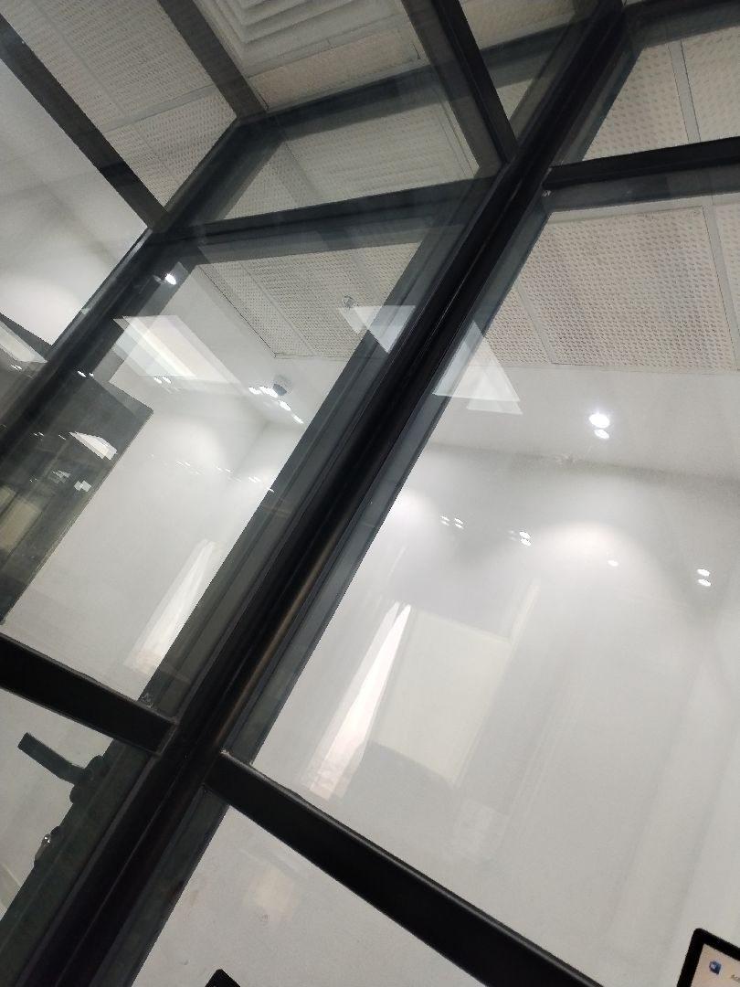

There are major defects in the basement waterproofing
Not Passed
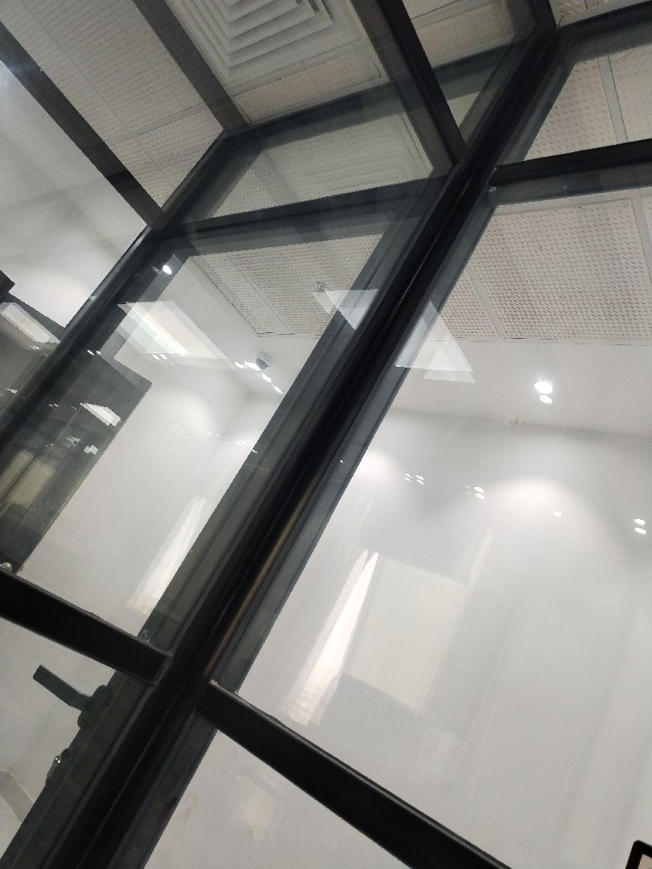

There are major defects in the basement waterproofing
Not Passed
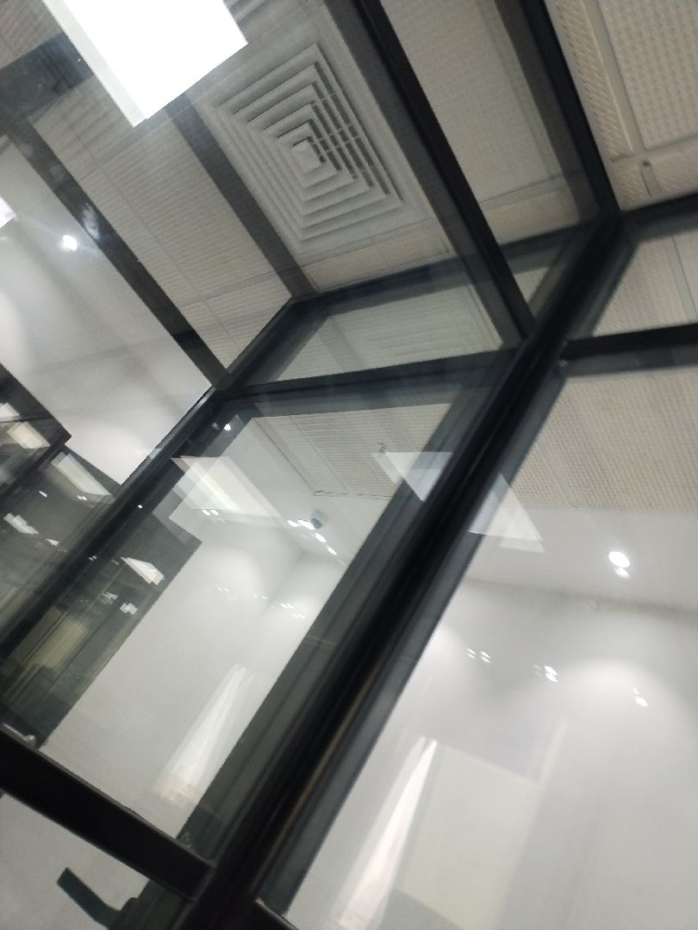

There are major defects in the facade waterproofing
Not Passed
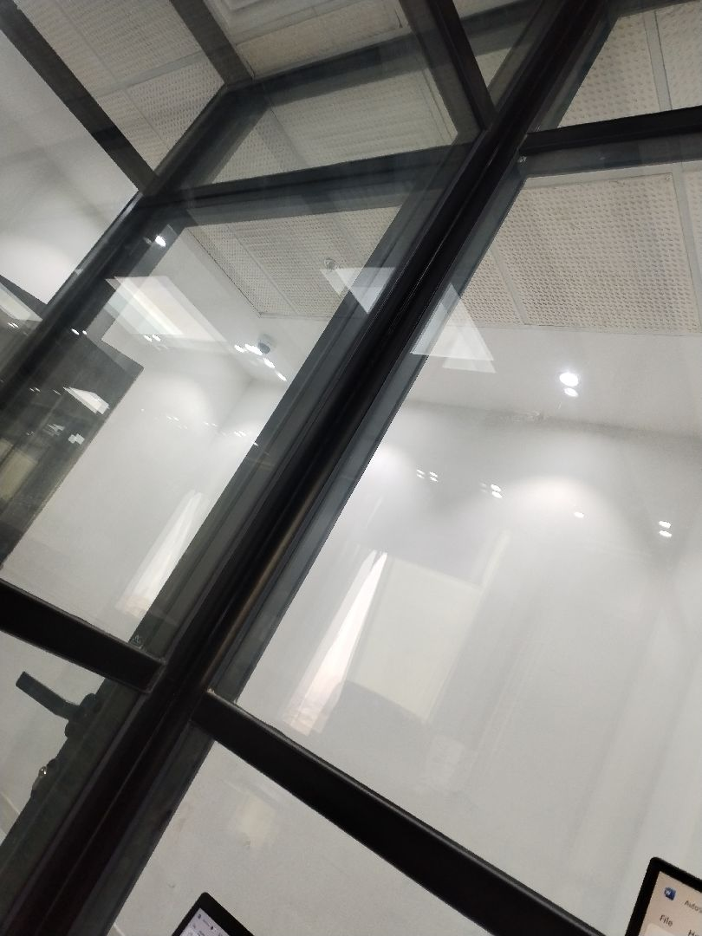

There are major defects in the facade waterproofing
Not Passed
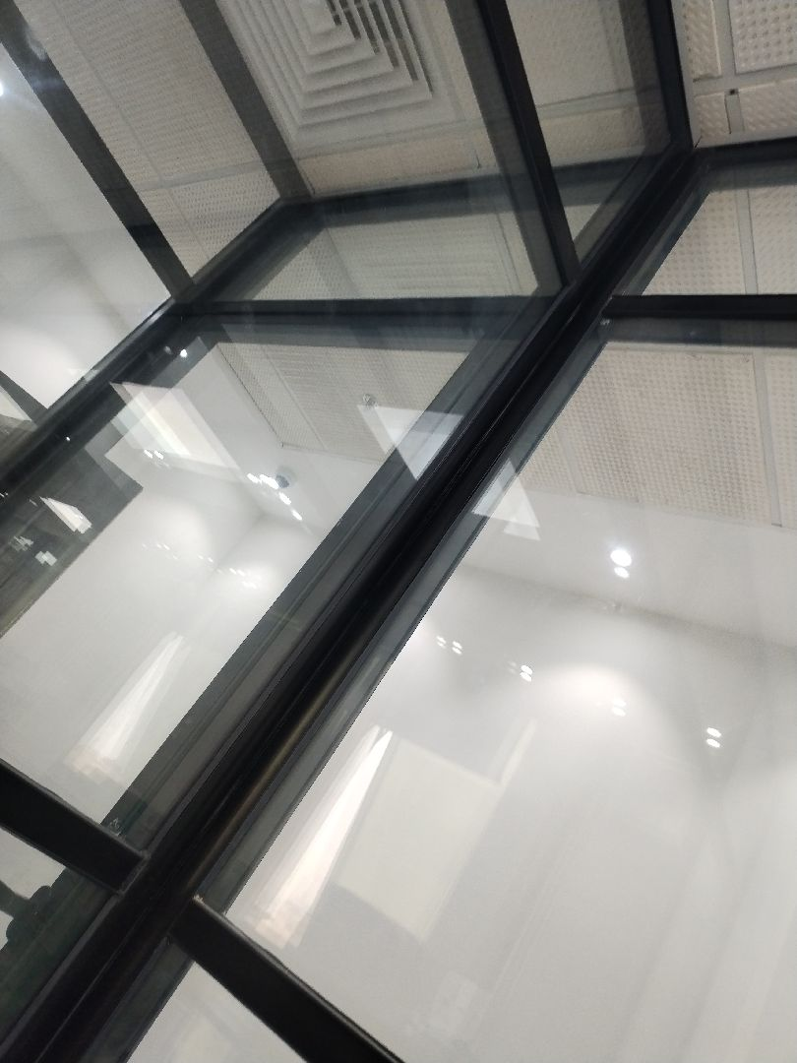

There are major defects in the roof waterproofing
Not Passed
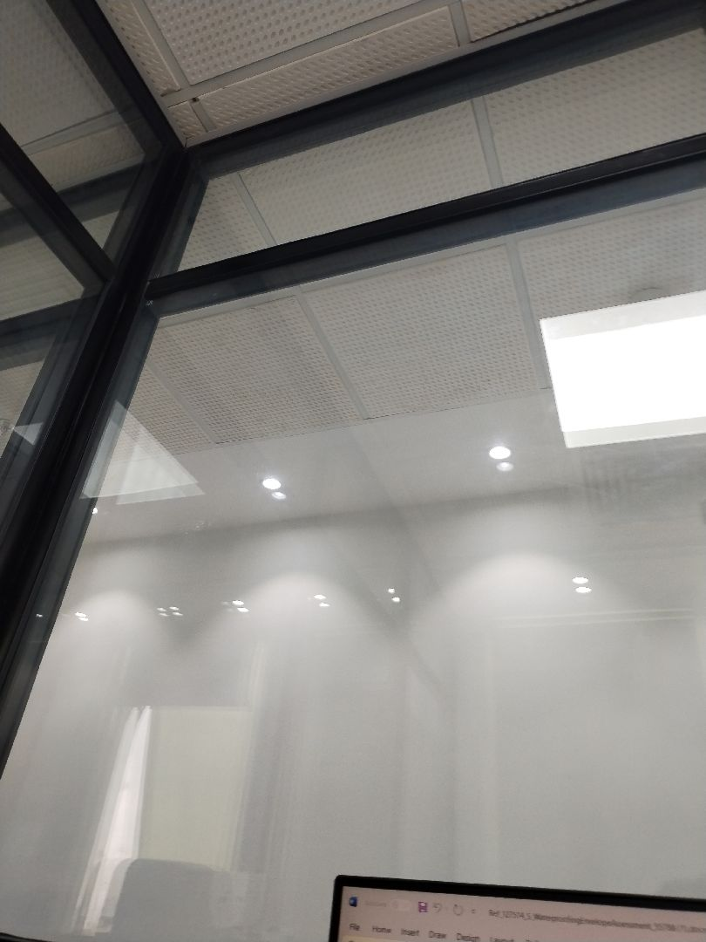

There are major defects in the roof waterproofing
Not Passed

Engineer In Charge of Inspection | Area Manager | Technical Inspection Manager
Name: Ahmed El Saeed | Name: | Name:
Signature:  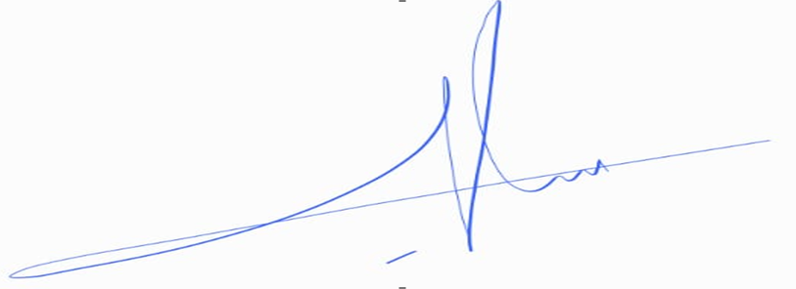 | Signature: | Signature:
Date of Issuing the report:

