${QR}

Attention to: ﻣﺆﺳﺴﺔ ﻣﺠﺎﻝ ﺍﻟﺘﻄﻮﻳﺮ ﻟﻠﻤﻘﺎﻭﻻﺕ ﺍﻟﻌﺎﻣﺔ

IDI PR #: 190897
Established by: Durid Mahrous

TIS Visit

Inspection Report - Waterproofing Envelope Assessment

Date of visit: 22-Jan-2025

Location: 24.6721881,46.7282668

( Inspection Department, Saudi Arabia)

Owner | ﺳﺎﻟﻢ ﻣﺤﻤﺪ ﺍﺑﻦ ﻋﺎﻳﺾ ﺍﻟﻘﺤﻄﺎﻧﻲ | TIS Company | CPV Arabia
Contractor | ﻣﺆﺳﺴﺔ ﻣﺠﺎﻝ ﺍﻟﺘﻄﻮﻳﺮ ﻟﻠﻤﻘﺎﻭﻻﺕ ﺍﻟﻌﺎﻣﺔ | Report Issue Date
Project Location | ﺍﻝ ﻗﻴﺸﻪ ﻭﺣﻤﻮﻣﻪ | Inspection # | 3
Inspection Stage | Waterproofing Envelope Assessment | No. Of buildings | 1
Inspector Name | Durid Mahrous | Work in progress | Waterproofing Envelope Assessment
Email | dmahrous@cpvarabia.com | Telephone | 581089419

Inspection Results: Satisfactory
Description of the inspections carried out:

CPV ARABIA has conducted an on-site technical inspection (IDI) for Project PR #190897 during the pre-pouring phase of the Waterproofing Envelope Assessment.

The details of the inspection are described further as we go through this report.
Summary

Risks may affect the building stability and stop the work (To be resolved by sending the required documents):
- Not exist
Stages missed without TIS involvement (To be resolved by performing the required tests for the missed elements):
- Not exist
Interpretation of Additional Visit:
- Not exist
Technical Reservations (To be closed by providing the required certificates and reports before the final visit):
- Not exist
Note:
- Not exist

General Site Pictures and Construction Plans
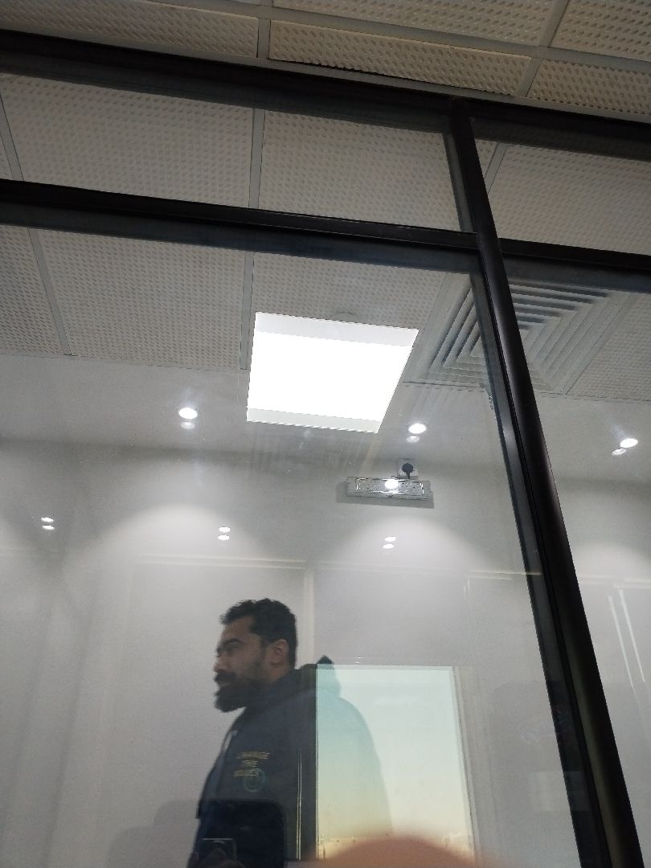

General site picture and construction plans

Risk Assessment

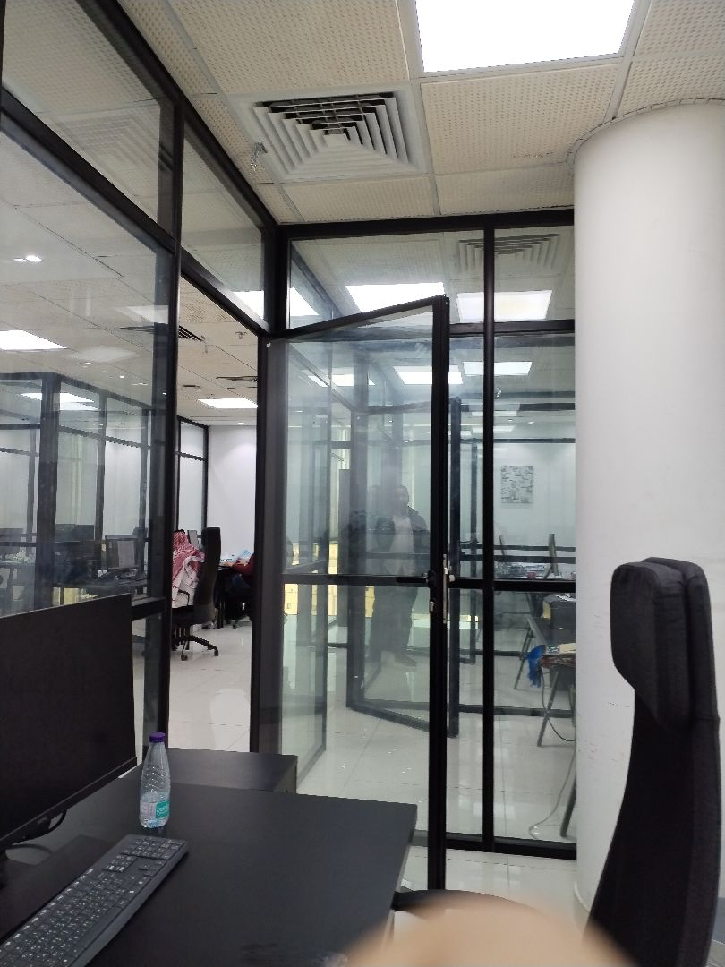

There are no defects in the facade waterproofing
Passed
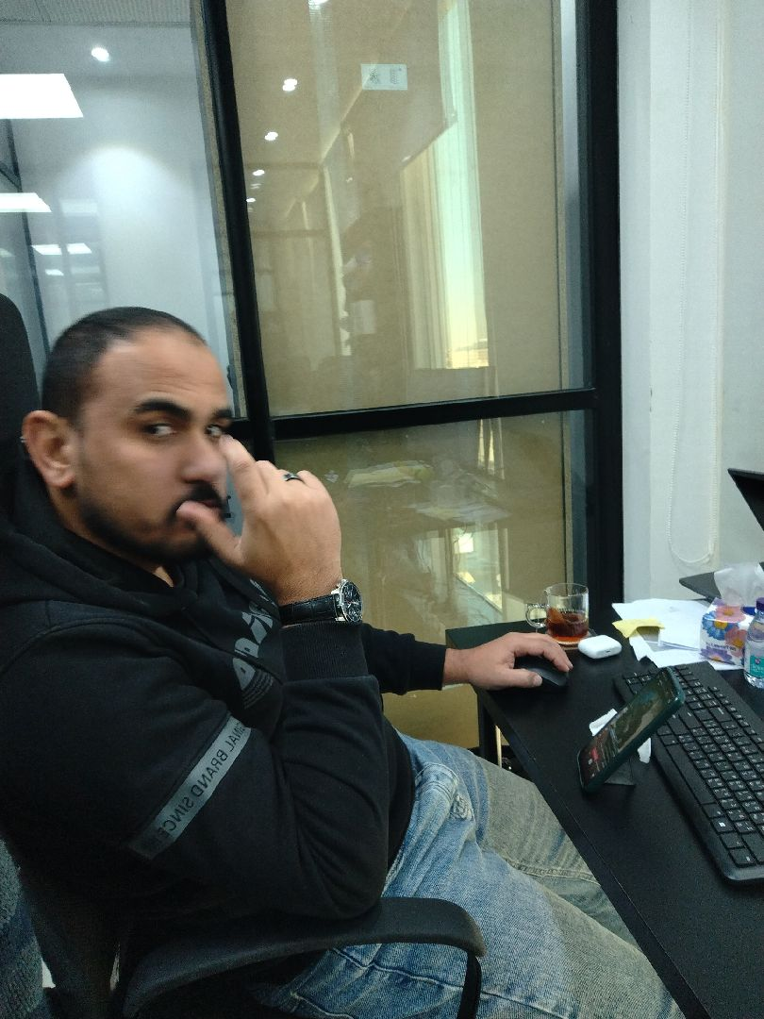

There are no defects in the facade waterproofing
Passed
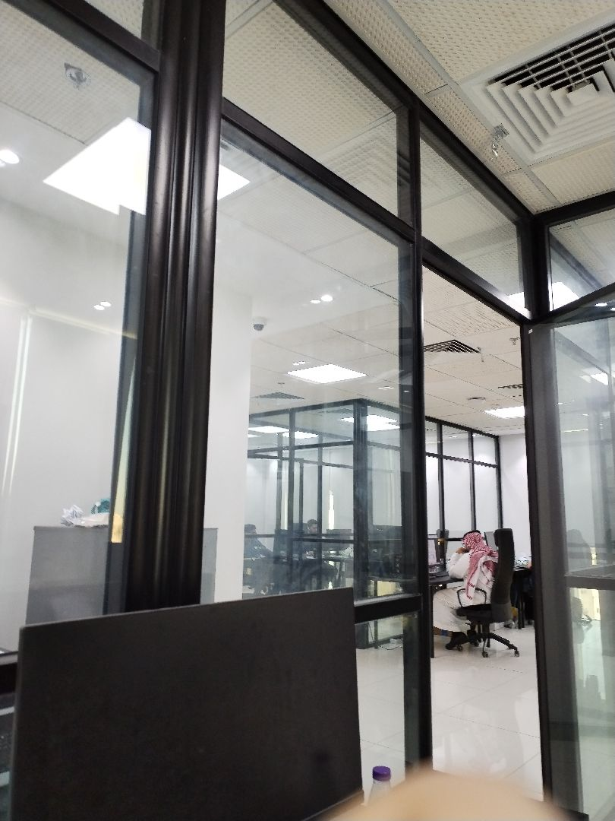

There are no defects in the facade waterproofing
Passed
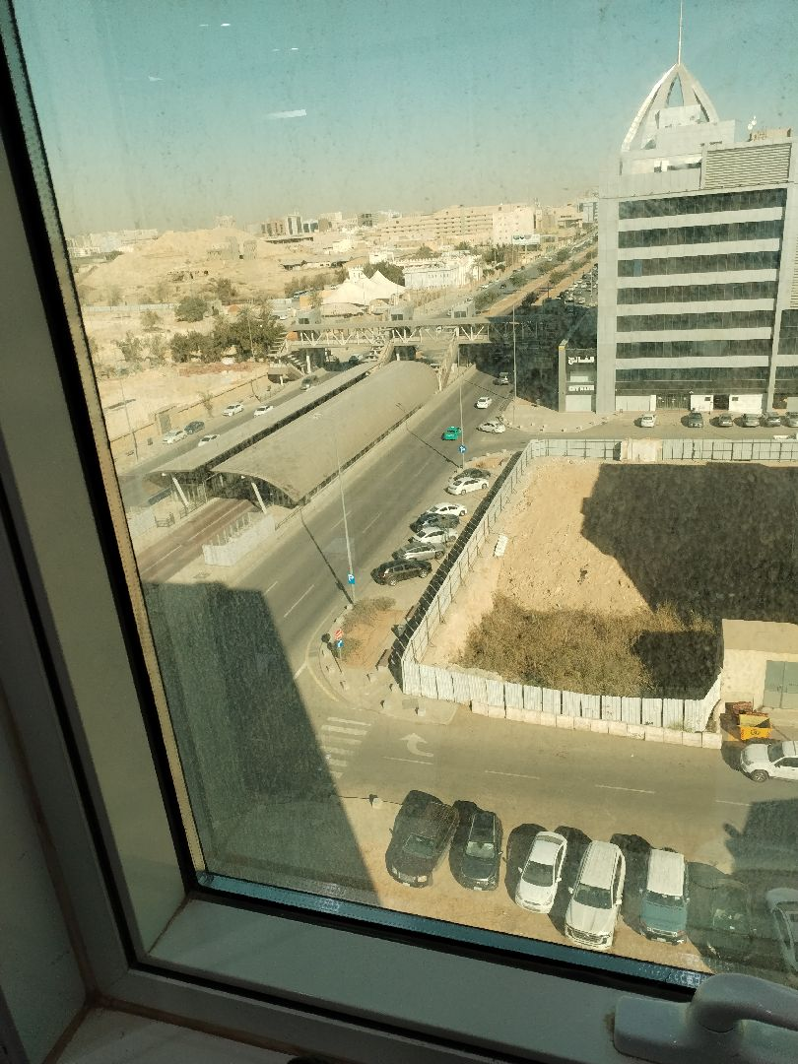

There are no defects in the facade waterproofing
Passed
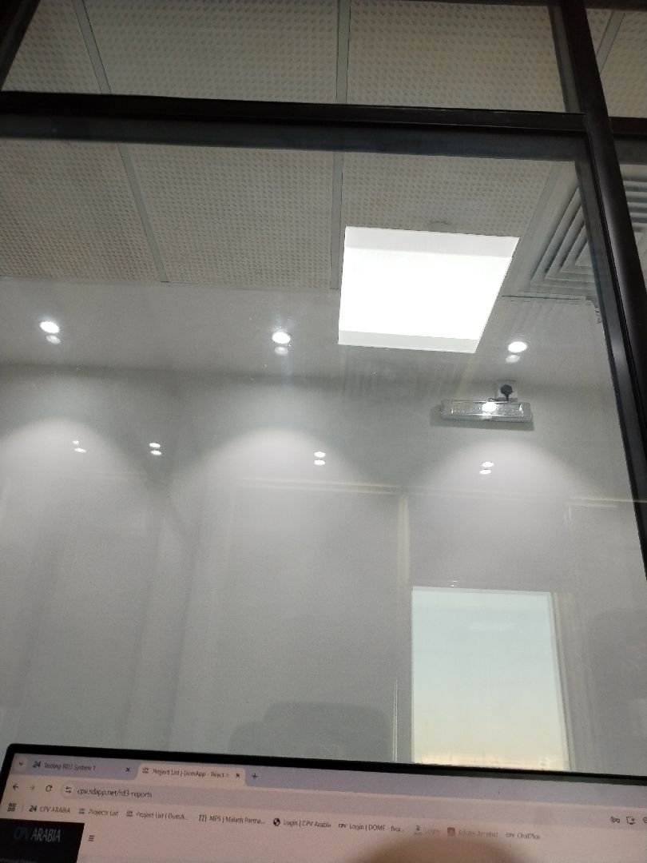

There are no defects in the roof waterproofing
Passed
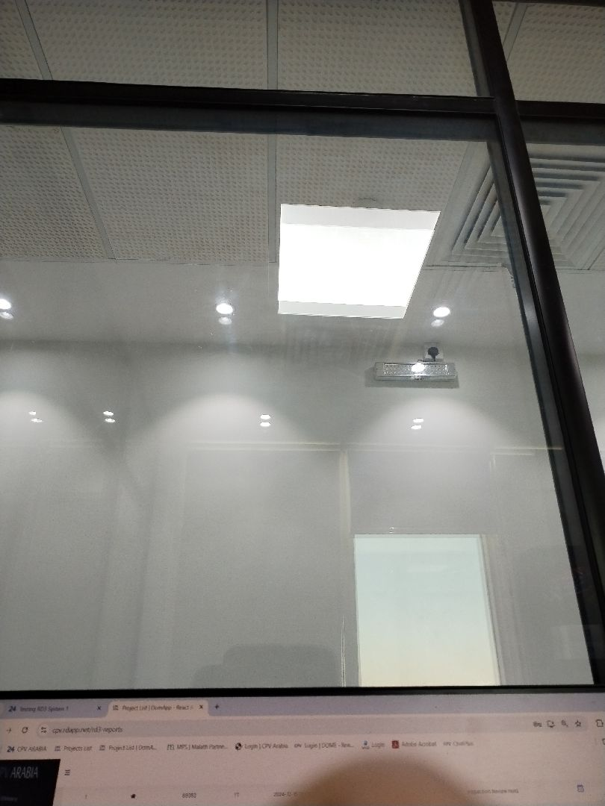

There are no defects in the roof waterproofing
Passed
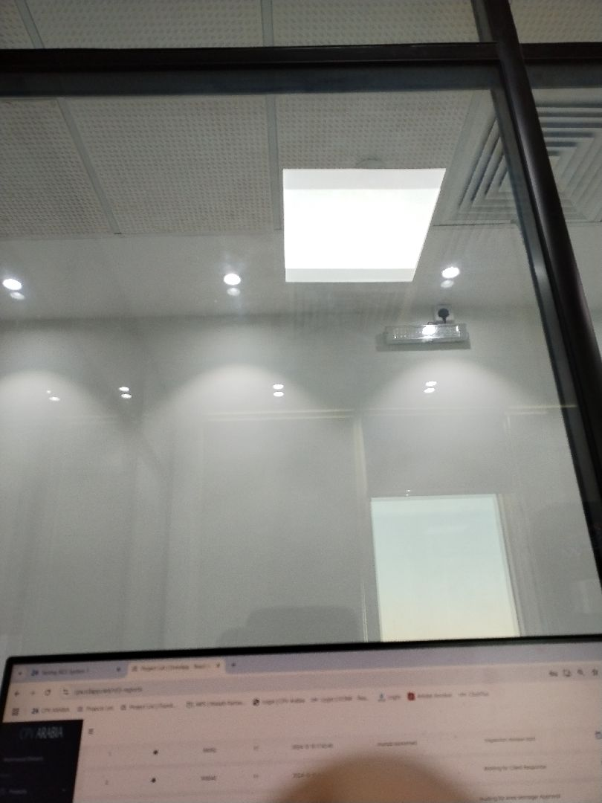

There are no defects in the roof waterproofing
Passed
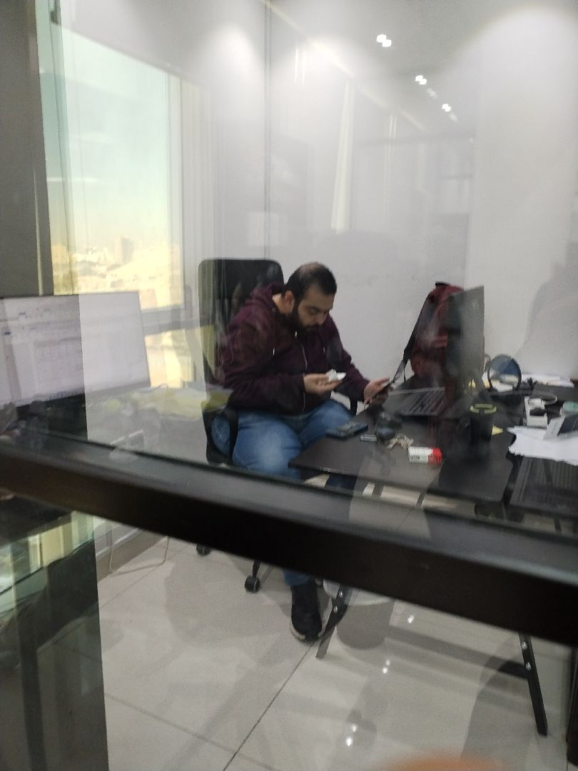

There are no defects in the roof waterproofing
Passed

Engineer In Charge of Inspection | Area Manager | Technical Inspection Manager
Name: Durid Mahrous | Name: | Name:
Signature:  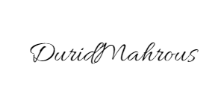 | Signature: | Signature:
Date of Issuing the report:

