${QR}

Attention to: ﻣﺆﺳﺴﺔ ﺑﻨﺎﺀ ﺻﺎﻟﺢ ﻫﺎﺩﻱ ﺍﻝ ﺷﻬﻲ ﻟﻠﻤﻘﺎﻭﻻﺕ

IDI PR #: 247116
Established by: Hussain Alsoltan

TIS Visit

Inspection Report - Waterproofing Envelope Assessment

Date of visit: 22-Jan-2025

Location: 24.6722041,46.7283015

( Dammam Branch, Saudi Arabia)

Owner | ﻓﺮﻳﺢ ﺑﻦ ﻓﻬﻴﺪ ﺑﻦ ﻓﺮﻳﺢ ﺍﻟﺸﻤﺮﻱ | TIS Company | CPV Arabia
Contractor | ﻣﺆﺳﺴﺔ ﺑﻨﺎﺀ ﺻﺎﻟﺢ ﻫﺎﺩﻱ ﺍﻝ ﺷﻬﻲ ﻟﻠﻤﻘﺎﻭﻻﺕ | Report Issue Date
Project Location | ﺣﻲ ﺍﻟﺼﻔﺎﺀ | Inspection # | 2
Inspection Stage | Waterproofing Envelope Assessment | No. Of buildings | 1
Inspector Name | Hussain Alsoltan | Work in progress | Waterproofing Envelope Assessment
Email | halsoltan@cpvarabia.com | Telephone | 581087674

Inspection Results: Additional Vsit
Description of the inspections carried out:

CPV ARABIA has conducted an on-site technical inspection (IDI) for Project PR #247116 during the pre-pouring phase of the Waterproofing Envelope Assessment.

The details of the inspection are described further as we go through this report.
Summary

Risks may affect the building stability and stop the work (To be resolved by sending the required documents):
- Not exist
Stages missed without TIS involvement (To be resolved by performing the required tests for the missed elements):
- Not exist
Interpretation of Additional Visit:
- There are major defects in the basement waterproofing
Technical Reservations (To be closed by providing the required certificates and reports before the final visit):
- BACKFILL U/F PLATE LOAD TEST AND COMPACTION TEST
Note:
- Not exist

General Site Pictures and Construction Plans
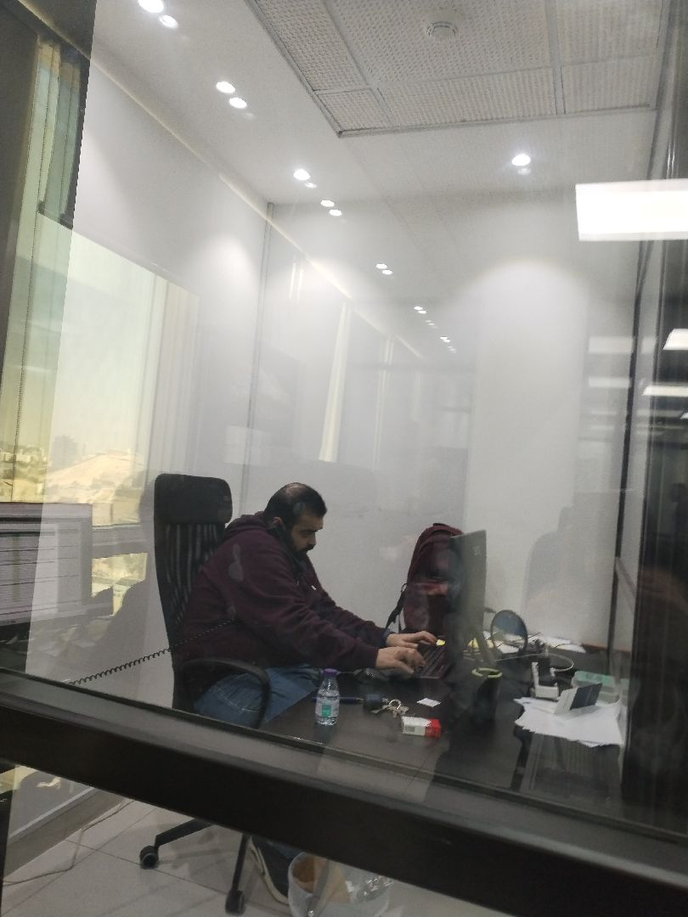

General site picture and construction plans

Risk Assessment

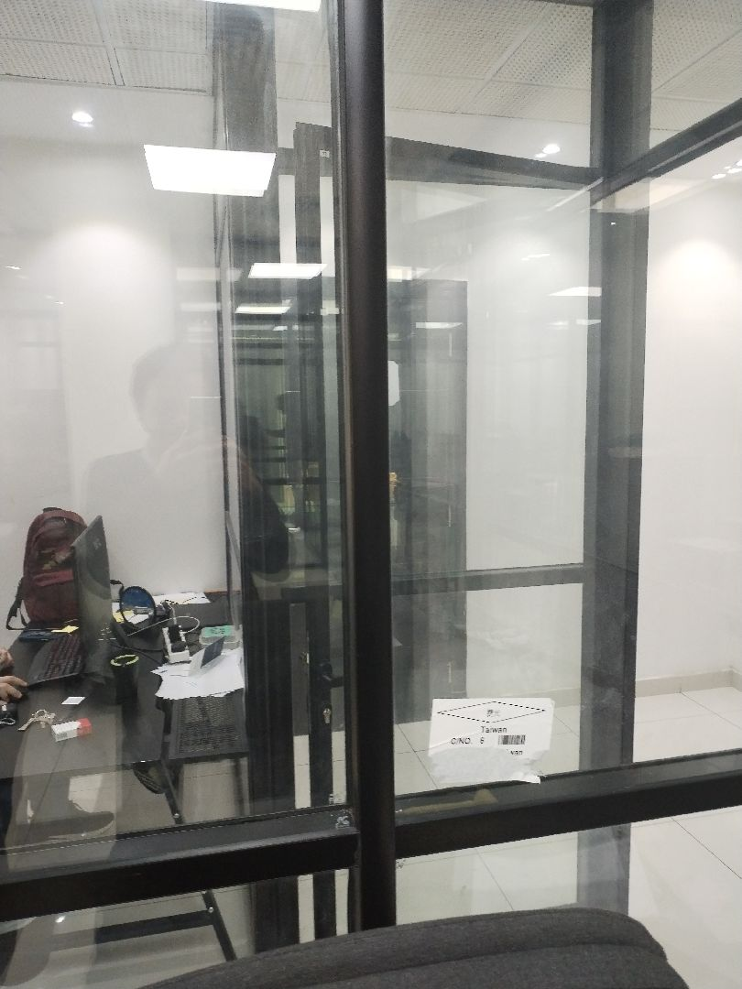

There are major defects in the basement waterproofing
Not Passed
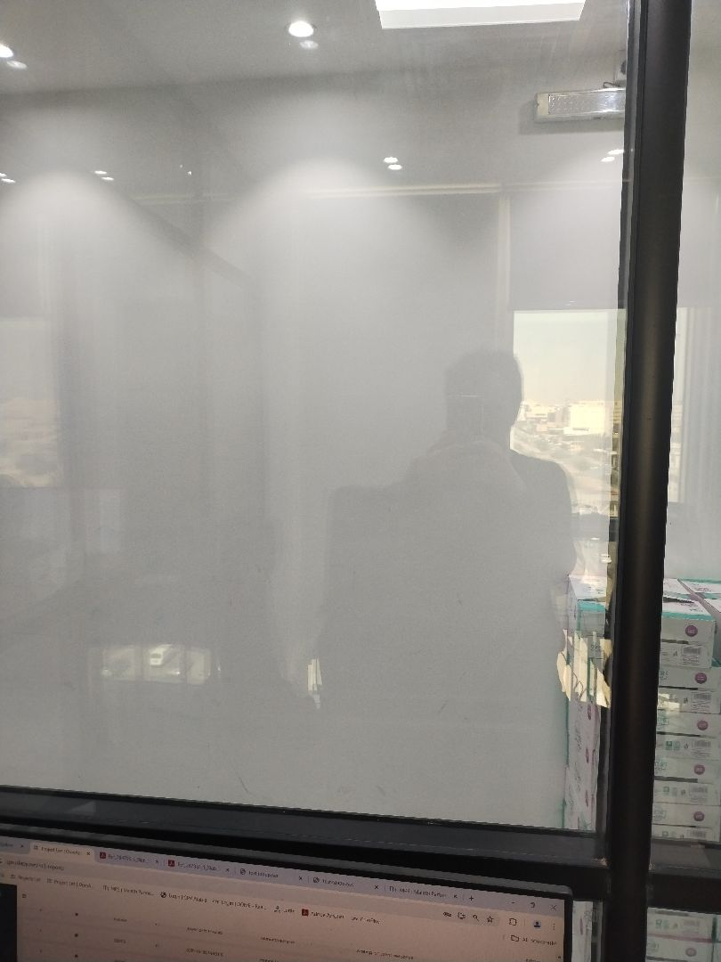

There are major defects in the basement waterproofing
Not Passed
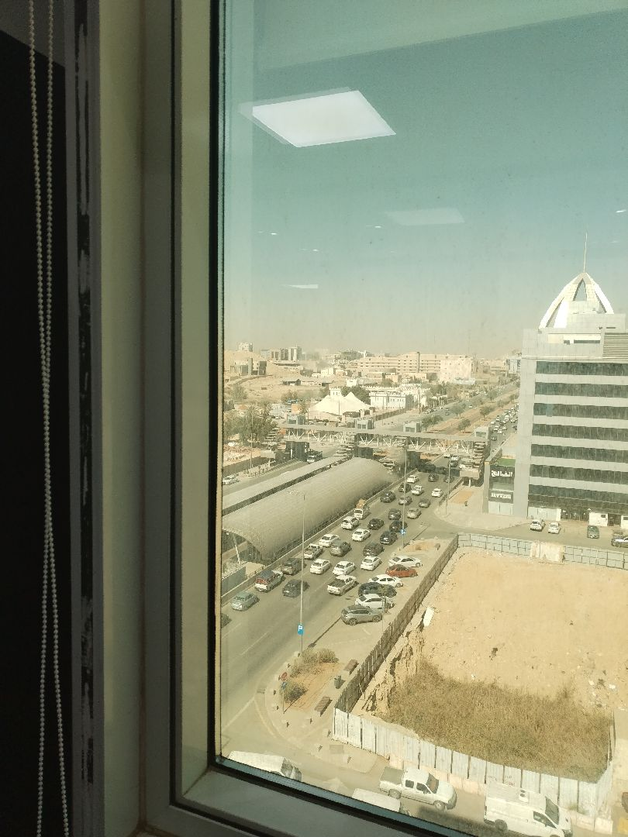

There are no defects in the facade waterproofing
Passed
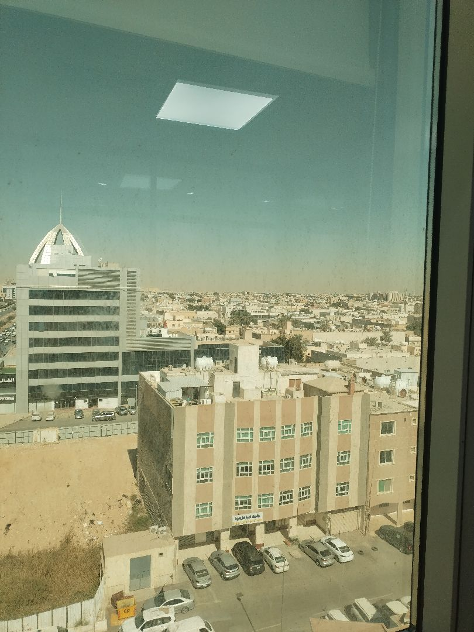

There are no defects in the facade waterproofing
Passed
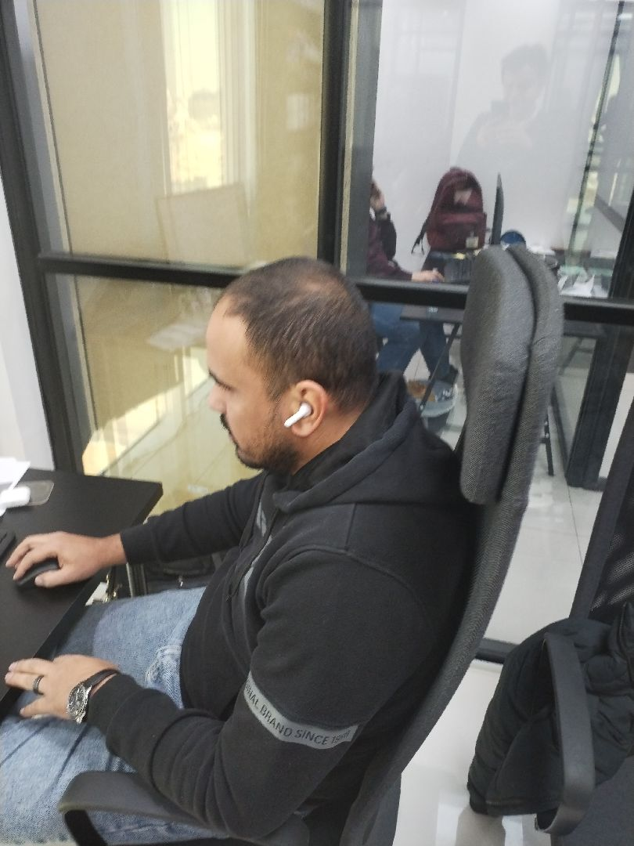

There are no defects in the facade waterproofing
Passed
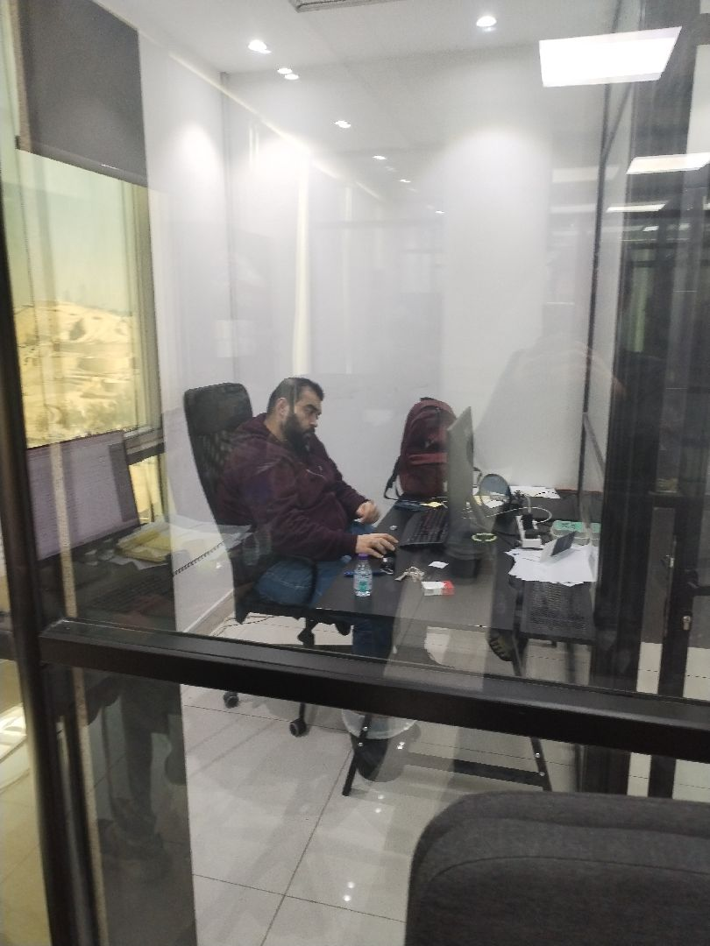

There are no defects in the facade waterproofing
Passed
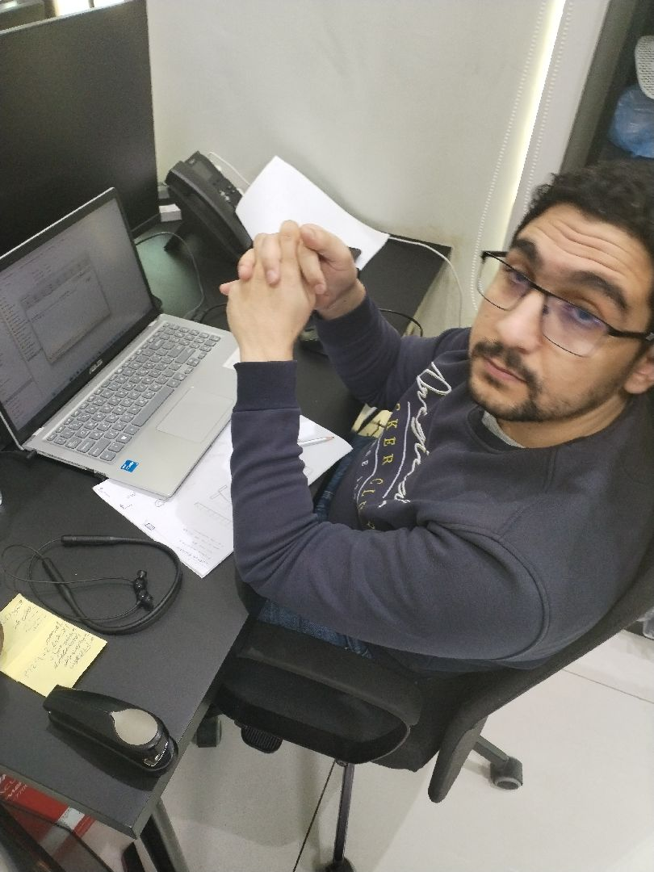

There are no defects in the roof waterproofing
Passed
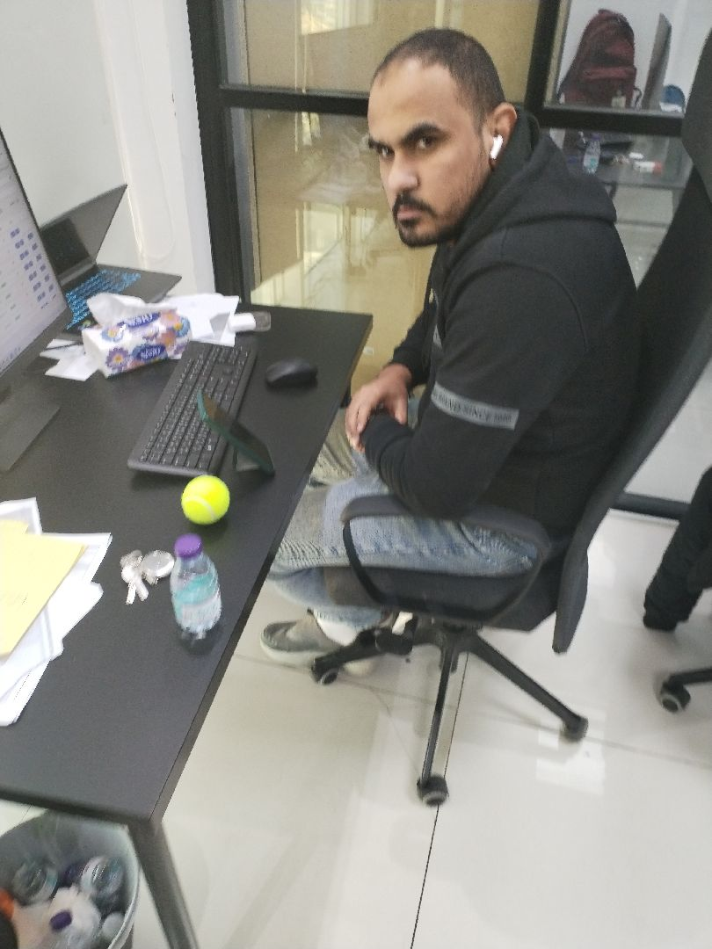

There are no defects in the roof waterproofing
Passed
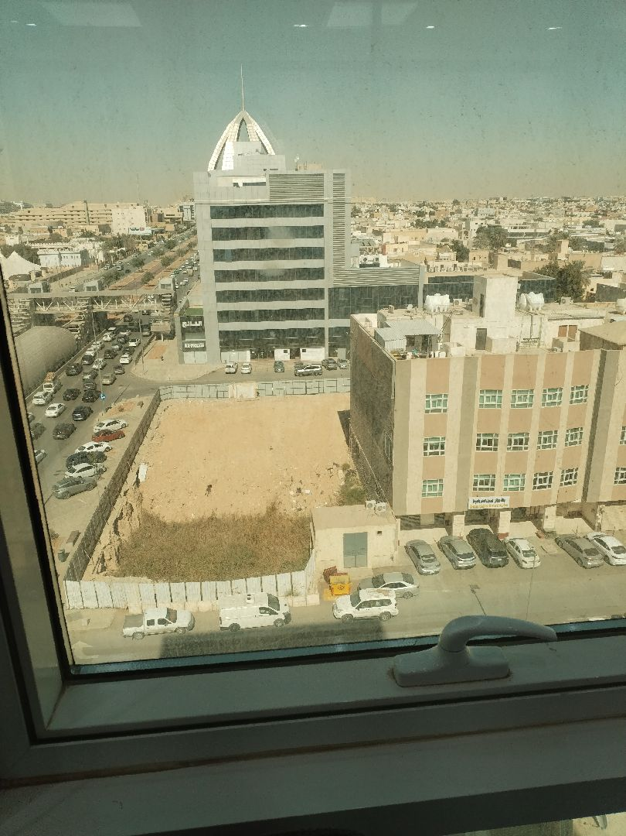

There are no defects in the roof waterproofing
Passed
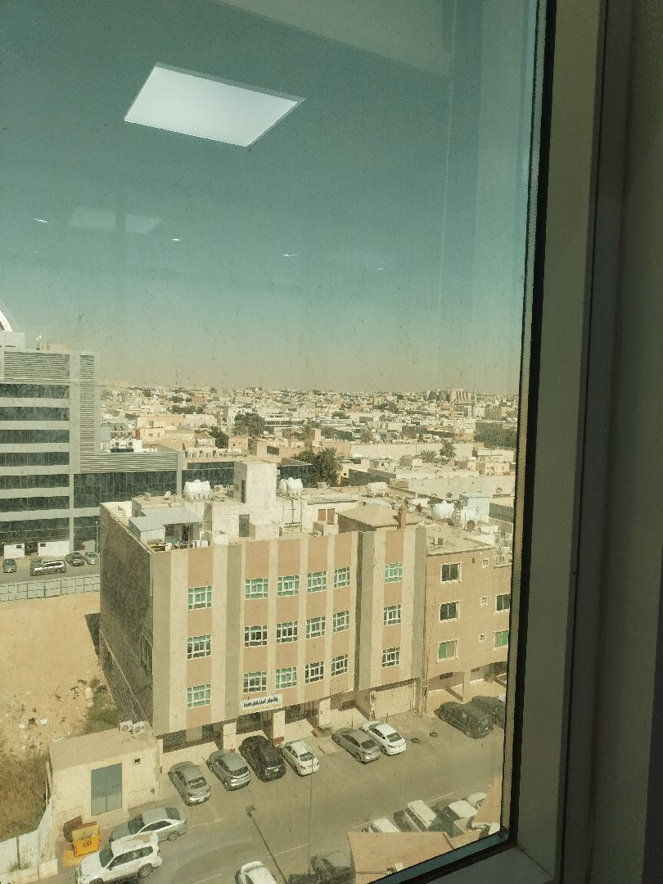

There are no defects in the roof waterproofing
Passed

Engineer In Charge of Inspection | Area Manager | Technical Inspection Manager
Name: Hussain Alsoltan | Name: | Name:
Signature:  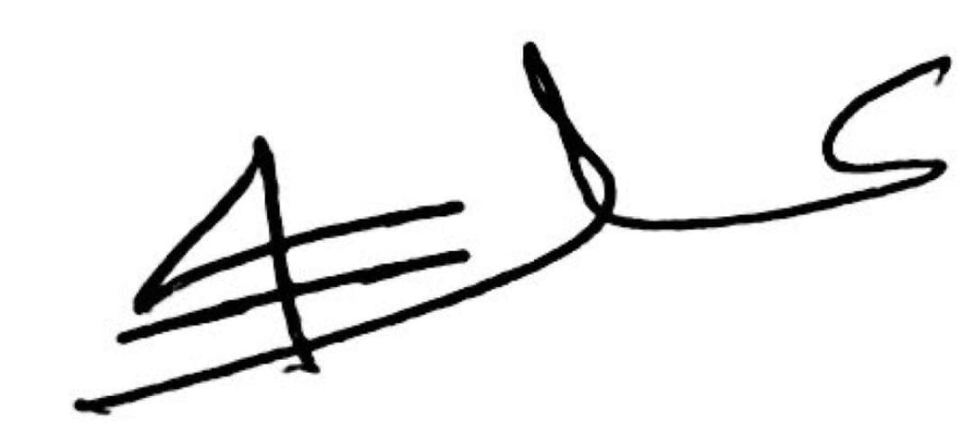 | Signature: | Signature:
Date of Issuing the report:

