${QR}

Attention to: ﺷﺮﻛﺔ ﺍﻟﻌﻤﺎﺭﺓ ﺍﻟﻤﻤﻴﺰﺓ ﻟﻠﻤﻘﺎﻭﻻﺕ ﺷﺮﻛﺔ ﺍﻟﺸﺨﺺ ﺍﻟﻮﺍﺣﺪ

IDI PR #: 293117
Established by: Amr Yasser

TIS Visit

Inspection Report - Soil Improvement

Date of visit: 21-Jan-2025

Location: 26.4355859,50.1021957

( Special Projects, Saudi Arabia)

Owner | ﺷﺮﻛﺔ ﻣﻨﺼﻮﺭ ﺑﻦ ﺟﻤﻌﻪ ﻭﺍﻭﻻﺩﻩ ﺍﻟﻘﺎﺑﻀﺔ ﻣﺴﺎﻫﻤﺔ ﻣﻘﻔﻠﺔ | TIS Company | CPV Arabia
Contractor | ﺷﺮﻛﺔ ﺍﻟﻌﻤﺎﺭﺓ ﺍﻟﻤﻤﻴﺰﺓ ﻟﻠﻤﻘﺎﻭﻻﺕ ﺷﺮﻛﺔ ﺍﻟﺸﺨﺺ ﺍﻟﻮﺍﺣﺪ | Report Issue Date
Project Location | ﺷﺎﺭﻉ ﺍﻻﻣﻴﺮ ﺗﺮﻙ ﺍﻟﺨﺒﺮ | Inspection # | 1
Inspection Stage | Soil Improvement | No. Of buildings | 1
Inspector Name | Amr Yasser | Work in progress | Soil Improvement( )
Email | ayasser@cpvarabia.com | Telephone | 594037209

Inspection Results: Satisfactory with Technical Reservation
Description of the inspections carried out:

CPV ARABIA has conducted an on-site technical inspection (IDI) for Project PR #293117 during the pre-pouring phase of the Soil Improvement.

The details of the inspection are described further as we go through this report.
Summary

Risks Assessment:
- Not exist
Stages missed without TIS involvement:
- Not exist
Interpretation of Additional Visit:
- Not exist

General Site Pictures and Construction Plans
${GImg}

General site picture and construction plans

Checklist

No | Checklist | SBC Reference | Result | Remarks
1 | Inspection criteria
1.1 | Is the site ready for inspection with safe inspection conditions and safe access for the TIS inspection? | - | Passed
1.2 | Were there any modifications in the project that is different from the RD0, Soil Report and Construction Plans...etc.)? | - | Passed
1.3 | Is there any missing inspection stages in the project? | - | Passed
1.4 | Are there any defects observed that can affect the building’s stability or RD5 inspection for slab stage hasn’t been closed yet? |  | Passed
1.5 | Is the laboratory conducting tests certified by an ISO/17025-accredited body? | - | NA
2 | Checklist
2.1 | Are there any visible signs of inadequate compaction, such as surface irregularities or material segregation? | - | Not Passed
2.2 | Are the area cleared of debris, vegetation, and loose soil? | - | Passed
2.3 | Does the soil classification report been provided and Soil type match the approved specifications? | - | Passed
2.4 | Are The compaction layer is uniform, and thickness matches with SBC specifications.? | - | Passed
2.5 | Do the Compaction equipment and methodology comply with the approved method statement? | - | Passed
2.6 | Does the moisture content of the soil match the optimum moisture content (OMC) as per the provided proctor test/modified proctor test results? | - | Passed
2.7 | are the Field dry density measured using approved methods (e.g., sand cone, nuclear gauge) as per test specifications? | - | Passed
2.8 | Are the compaction test results (Field compaction percentage) satisfactory and comply with SBC? | - | Passed
2.9 | Is the test area level, debris-free, and prepared according to the approved method statement? | - | Passed
2.10 | Are the load is applied incrementally as per approved standards (e.g., ASTM D1196)? | - | Passed
2.11 | Are The load-settlement relationship matches design requirements for bearing capacity and settlement limits? | - | Passed
2.12 | Is a detailed test report, including load-settlement curves and results provided? | - | Passed
2.13 | Are the compaction test results for the previous layers provided and verified on site? | - | Passed
2.14 | Does the test plate meet the specified dimensions and thickness? | - | Passed

Risk Assessment

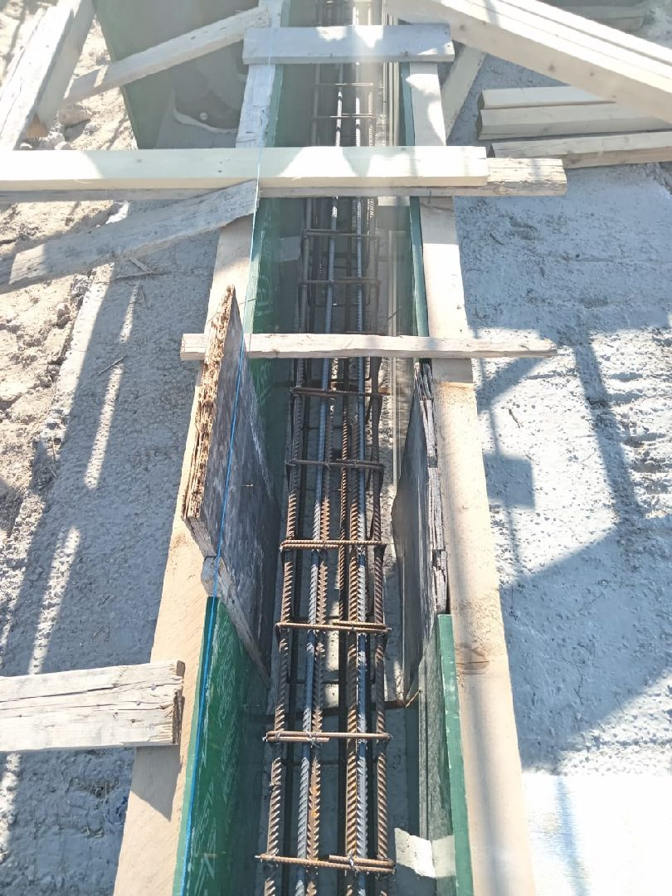

The plate diameter and thickness as per test specifications
Passed
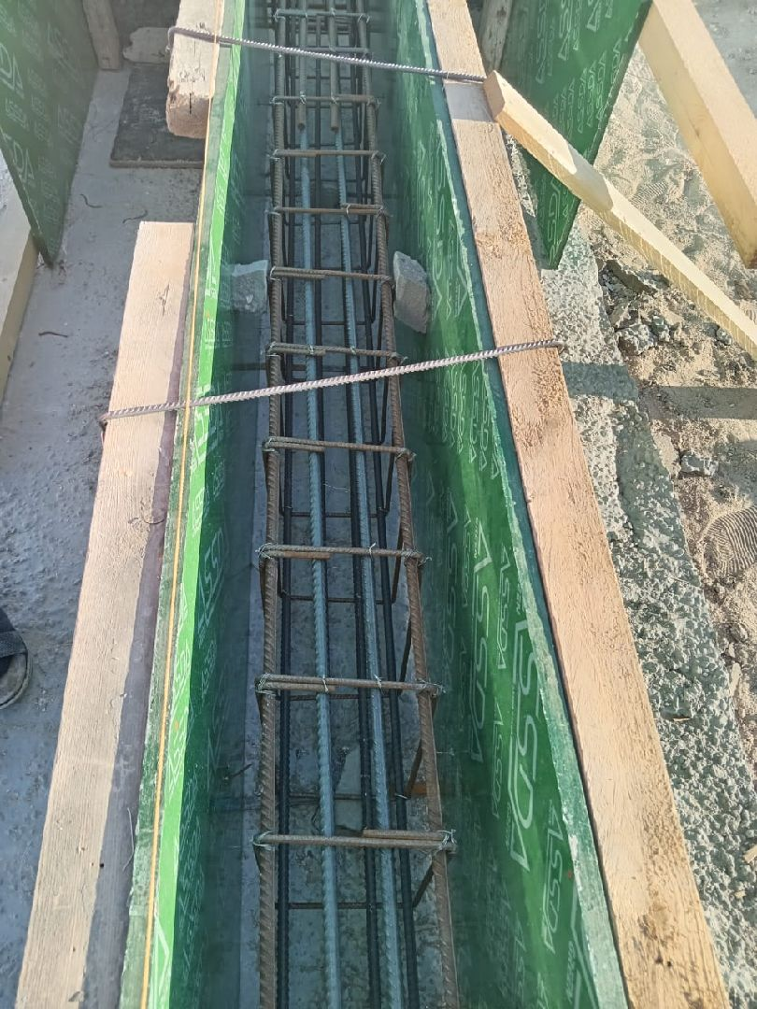

The compaction test results for the previous layers have been provided and verified on site .
Passed
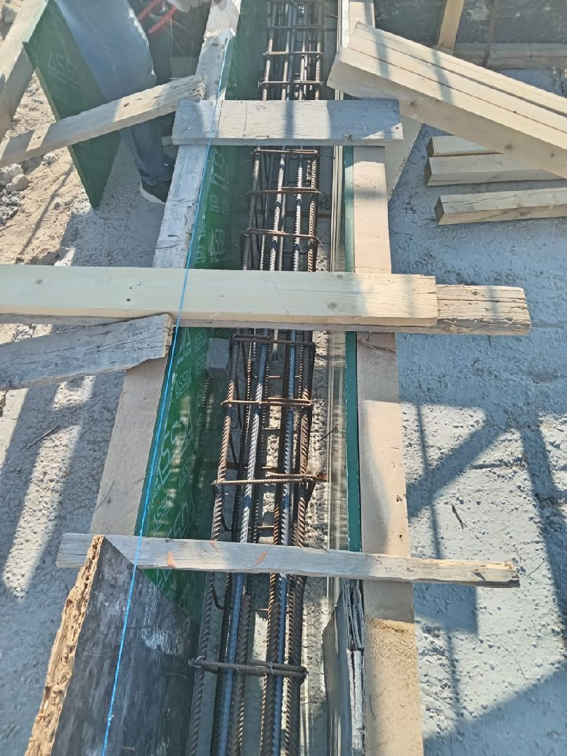

Test report is detailed, including load-settlement curves and results
Passed

The load-settlement relationship matches design requirements for bearing capacity and settlement limits
Passed

The load is applied incrementally as per approved standards (e.g., ASTM D1196).
Passed

The test area is level, free from debris, and prepared according to the approved method statement.
Passed

The field dry density measured using approved methods (e.g., sand cone, nuclear gauge) complies with the test specifications
Passed

The compaction test results (Field compaction percentage) are satisfactory and comply with SBC
Passed

The moisture content of the soil is within the optimum moisture content (OMC) based on the provided proctor test results.
Passed

The compaction equipment and methodology comply with the approved method statement.
Passed

The compaction layer is uniform, and its thickness conforms to SBC specifications.
Passed

The soil classification report has been provided, and the soil type matches the approved specifications.
Passed

the area cleared of debris, vegetation, and loose soil
Passed
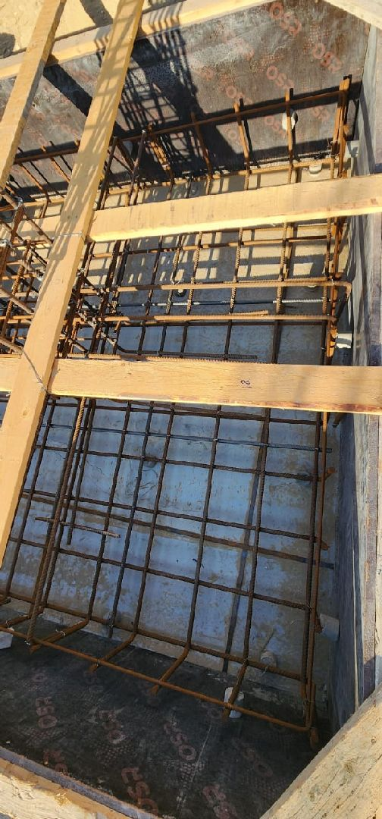

There are visible signs inadequate compaction, and surface irregularities or material segregation
Not Passed

Engineer In Charge of Inspection | Special Projects Manager | Technical Inspection Manager
Name: Amr Yasser | Name: | Name:
Signature:   | Signature: | Signature:
Date of Issuing the report:

