${QR}

Attention to: ﻣﺆﺳﺴﺔ ﺻﺎﻟﺢ ﻋﺒﺪﺍﻟﺮﺣﻤﻦ ﻣﺤﻤﺪ ﺍﻻﺯﻫﺮﻱ ﻟﻠﻤﻘﺎﻭﻻﺕ ﺍﻟﻌﺎﻣﺔ

IDI PR #: 78979
Established by: Mohamed Eldapess

TIS Visit

Inspection Report - Waterproofing Envelope Assessment

Date of visit: 04-Feb-2025

Location: 24.6722604,46.7283503

( North Riyadh, Saudi Arabia)

Owner | ﺍﻳﻤﻦ ﺳﻌﻴﺪ ﺍﺑﻦ ﺻﺎﻟﺢ ﺍﻟﻐﺎﻣﺪﻱ | TIS Company | CPV Arabia
Contractor | ﻣﺆﺳﺴﺔ ﺻﺎﻟﺢ ﻋﺒﺪﺍﻟﺮﺣﻤﻦ ﻣﺤﻤﺪ ﺍﻻﺯﻫﺮﻱ ﻟﻠﻤﻘﺎﻭﻻﺕ ﺍﻟﻌﺎﻣﺔ | Report Issue Date
Project Location | ﺍﻟﻤﺪﻳﻨﺔ ﺍﻟﻤﻨﻮﺭﺓ ﺧﻠﻒ ﺍﻟﺠﻮﺍﺯﺍﺕ ﺣﻲ ﺍﻟﺮﻭﺍﺑﻲ ﺷﻮﺭﺍﻥ | Inspection # | 1
Inspection Stage | Waterproofing Envelope Assessment | No. Of buildings | 1
Inspector Name | Mohamed Eldapess | Work in progress | Waterproofing Envelope Assessment
Email | meldapess@cpvarabia.com | Telephone | 581082681

Inspection Results: Additional Vsit
Description of the inspections carried out:

CPV ARABIA has conducted an on-site technical inspection (IDI) for Project PR #78979 during the pre-pouring phase of the Waterproofing Envelope Assessment.

The details of the inspection are described further as we go through this report.
Summary

Risks may affect the building stability and stop the work (To be resolved by sending the required documents):
- Not exist
Stages missed without TIS involvement (To be resolved by performing the required tests for the missed elements):
- Not exist
Interpretation of Additional Visit:
- There are major defects in the facade waterproofing
Technical Reservations (To be closed by providing the required certificates and reports before the final visit):
- Not exist
Note:
- Not exist

General Site Pictures and Construction Plans
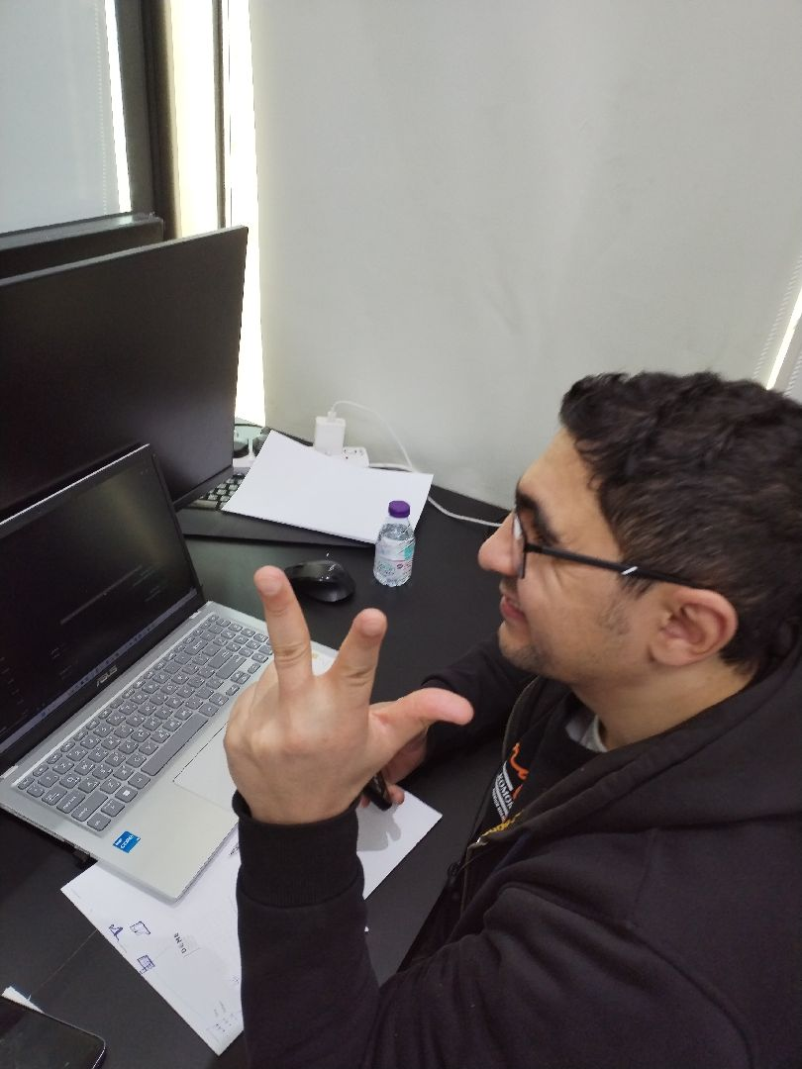

General site picture and construction plans

Risk Assessment

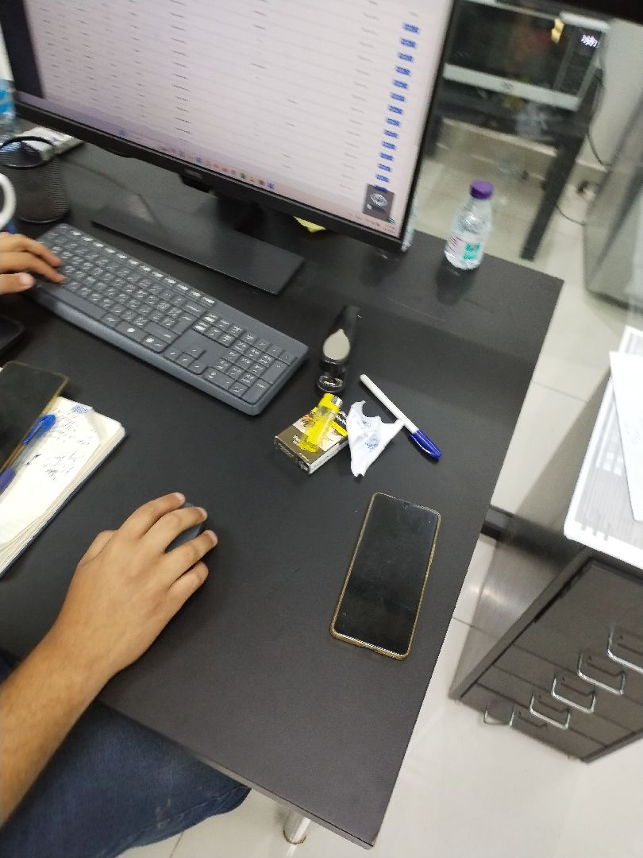

There are no defects in the basement waterproofing
Passed
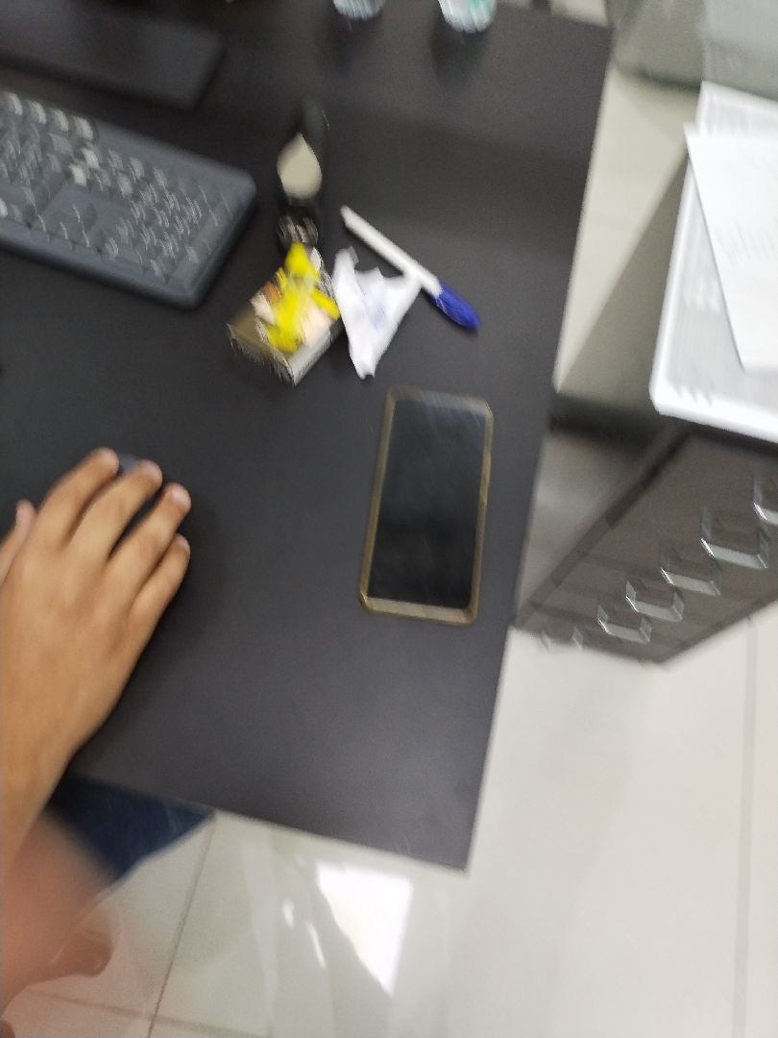

There are no defects in the basement waterproofing
Passed
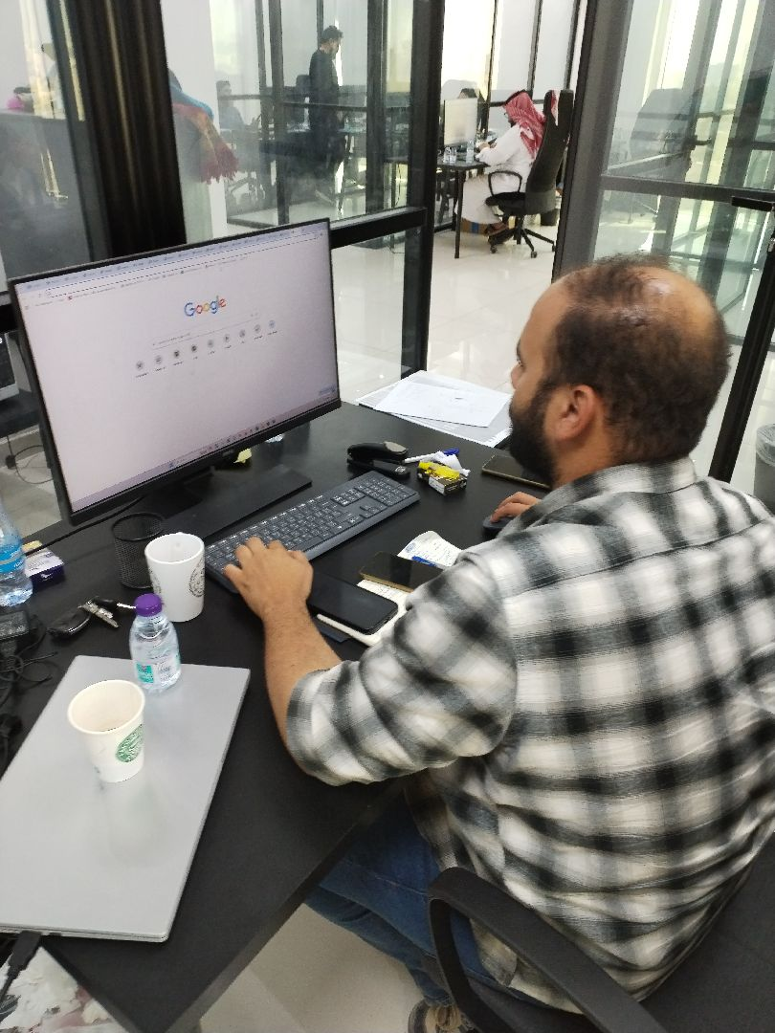

There are major defects in the facade waterproofing
Not Passed
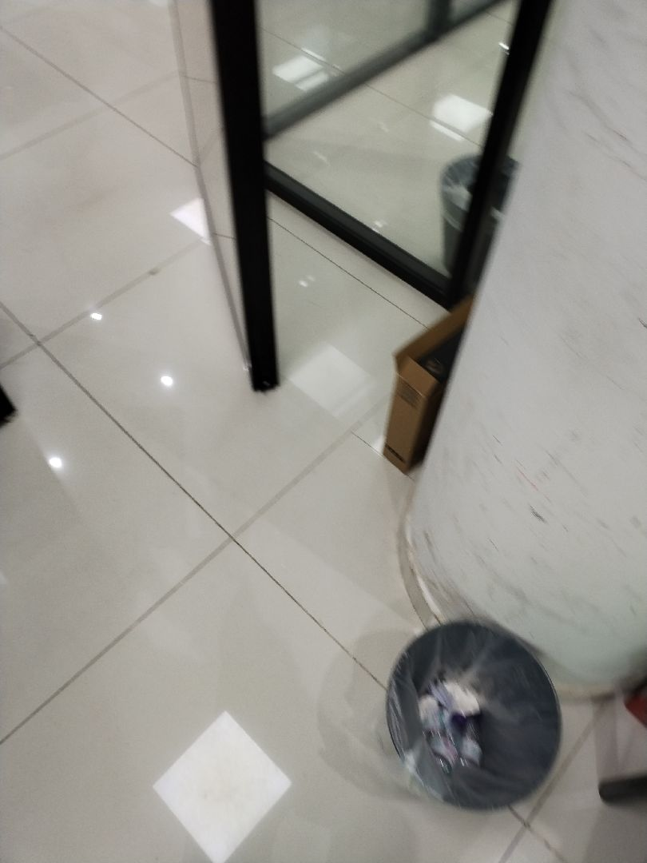

There are major defects in the facade waterproofing
Not Passed
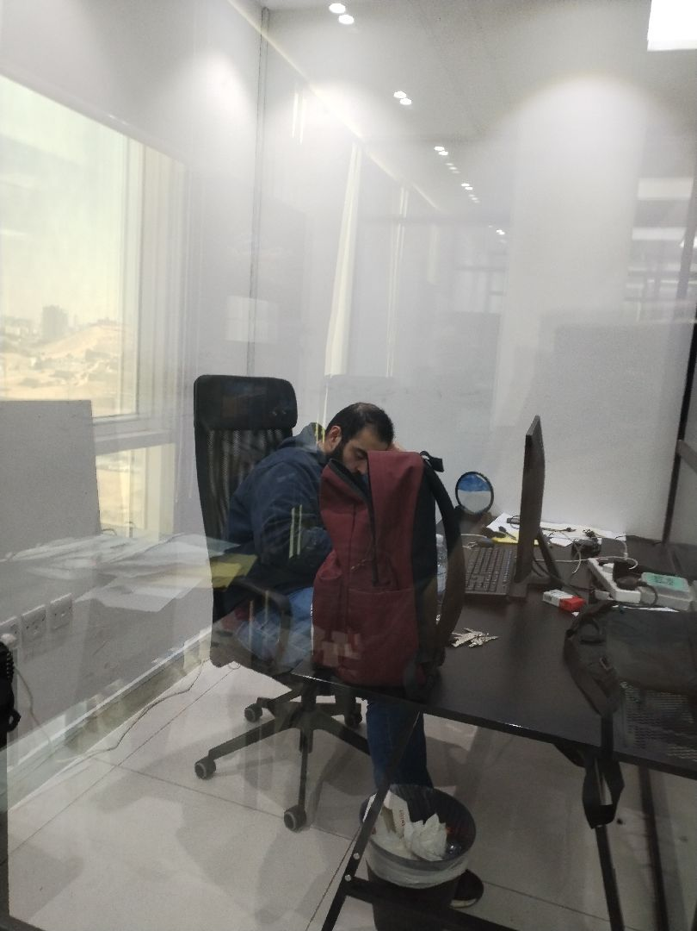

There are no defects in the roof waterproofing
Passed
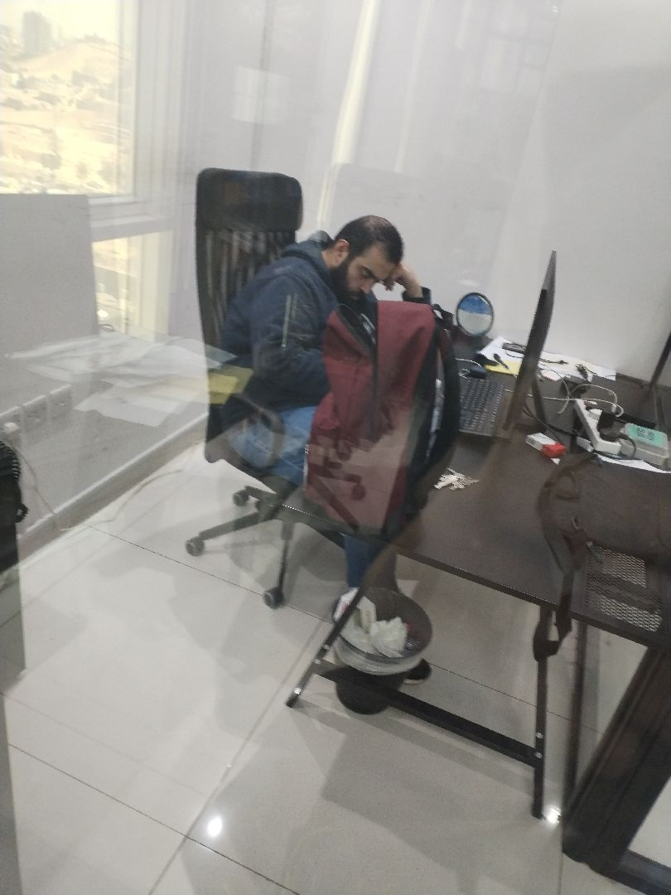

There are no defects in the roof waterproofing
Passed
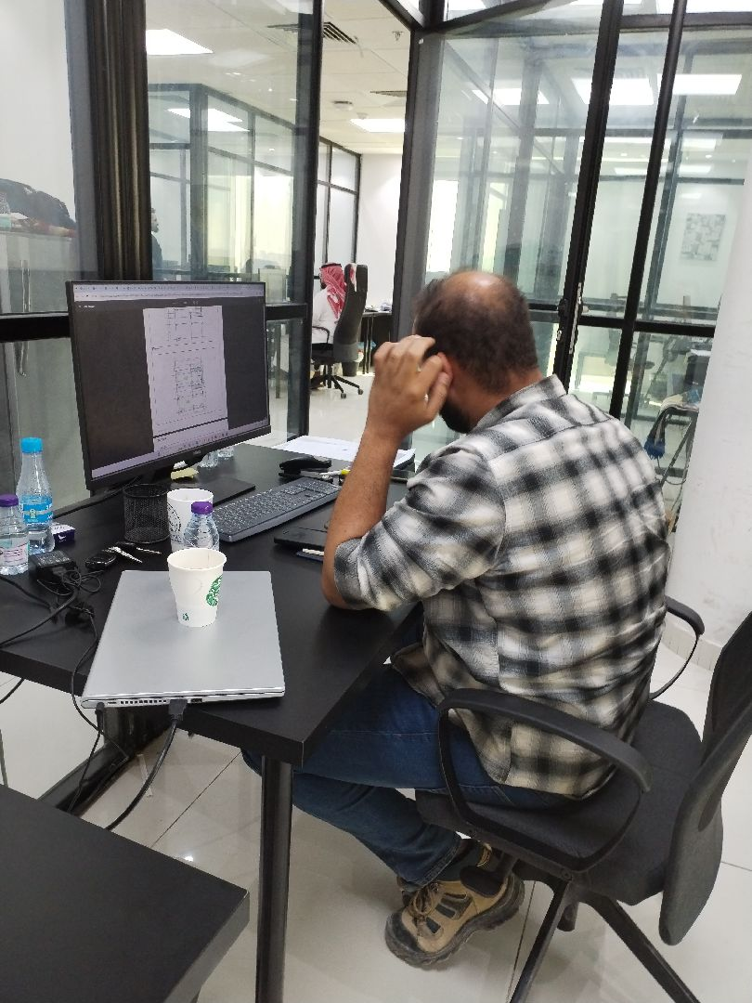

There are no defects in the roof waterproofing
Passed
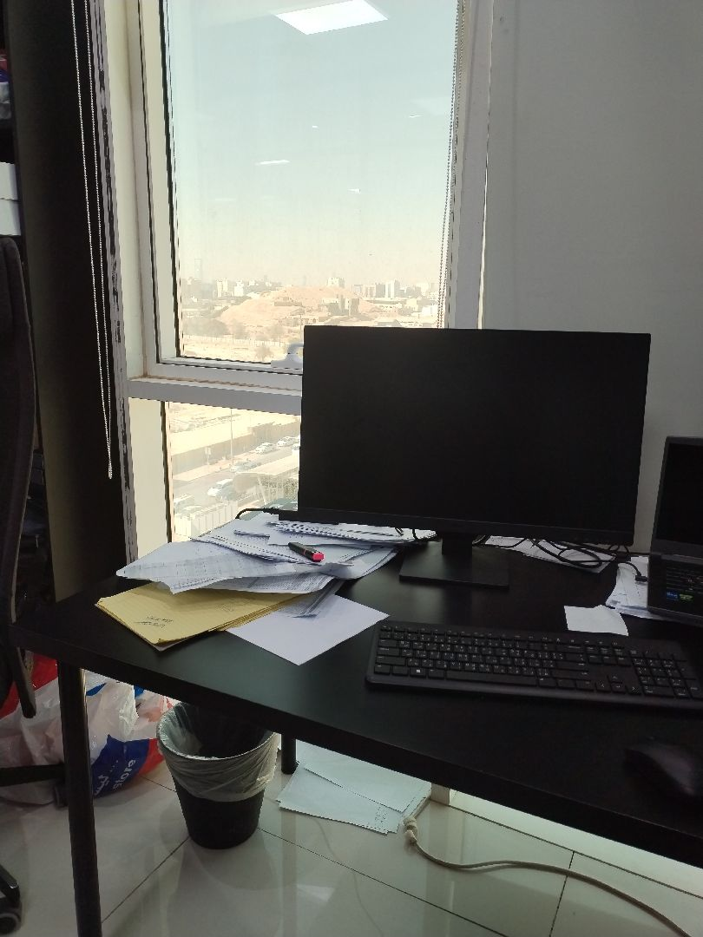

There are no defects in the roof waterproofing
Passed

Engineer In Charge of Inspection | Area Manager | Technical Inspection Manager
Name: Mohamed Eldapess | Name: | Name:
Signature:  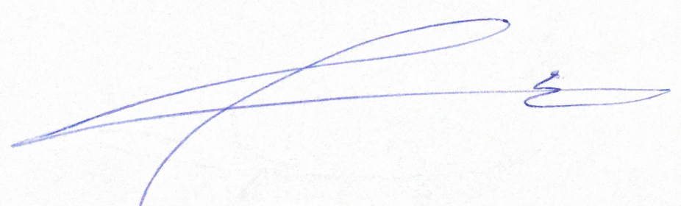 | Signature: | Signature:
Date of Issuing the report:

