${QR}

Attention to: ﻣﺆﺳﺴﺔ ﺛﺎﻳﺐ ﺑﻦ ﻋﻮﻳﺾ ﺑﻦ ﻋﺎﻳﺪ ﺍﻟﻤﻄﻴﺮﻱ ﻟﻠﻤﻘﺎﻭﻻﺕ

IDI PR #: 92003
Established by: Mohamed Eldapess

TIS Visit

Inspection Report - Soil Improvement

Date of visit: 26-Feb-2025

Location: 24.6722642,46.7283022

( North Riyadh, Saudi Arabia)

Owner | ﻣﺆﺳﺴﺔ ﻣﺸﻌﻞ ﻓﻬﻴﺪ ﺣﺒﻴﻠﻴﺺ ﺍﻟﻤﻄﻴﺮﻱ ﻟﻠﺘﻄﻮﻳﺮ ﺍﻟﻌﻘﺎﺭﻱ | TIS Company | CPV Arabia
Contractor | ﻣﺆﺳﺴﺔ ﺛﺎﻳﺐ ﺑﻦ ﻋﻮﻳﺾ ﺑﻦ ﻋﺎﻳﺪ ﺍﻟﻤﻄﻴﺮﻱ ﻟﻠﻤﻘﺎﻭﻻﺕ | Report Issue Date
Project Location | ﻋﻨﻴﺰﺓ | Inspection # | 1
Inspection Stage | Soil Improvement | No. Of buildings | 1
Inspector Name | Mohamed Eldapess | Work in progress | Soil Improvement
Email | meldapess@cpvarabia.com | Telephone | 581082681

Inspection Results: Satisfactory with Technical Reservation
Description of the inspections carried out:

CPV ARABIA has conducted an on-site technical inspection (IDI) for Project PR #92003 during the pre-pouring phase of the Soil Improvement.

The details of the inspection are described further as we go through this report.
Summary

Risks Assessment:
- Not exist
Stages missed without TIS involvement:
- Not exist
Interpretation of Additional Visit:
- Not exist
Technical Reservations (To be closed by providing the required certificates and reports before the final visit):
- The compaction test results (Field compaction percentage) unsatisfactory and do not comply with SBC The compaction test results (Field compaction percentage) should comply with SBC recommendations
Note:
- Not exist

General Site Pictures and Construction Plans



General site picture and construction plans

Checklist

No | Checklist | SBC Reference | Result | Remarks
1 | Inspection criteria
1.1 | Is the site ready for inspection with safe inspection conditions and safe access for the TIS inspection? | - | Passed
1.2 | Were there any modifications in the project that is different from the RD0, Soil Report and Construction Plans...etc.)? | - | Passed
1.3 | Is there any missing inspection stages in the project? | - | Passed
1.4 | Are there any defects observed that can affect the building’s stability or RD5 inspection for slab stage hasn’t been closed yet? |  | Passed
1.5 | Is the laboratory conducting tests certified by an ISO/17025-accredited body? | - | Passed
2 | Checklist
2.1 | Are there any visible signs of inadequate compaction, such as surface irregularities or material segregation? | - | Passed
2.2 | Are the area cleared of debris, vegetation, and loose soil? | - | Passed
2.3 | Does the soil classification report been provided and Soil type match the approved specifications? | - | Passed
2.4 | Are The compaction layer is uniform, and thickness matches with SBC specifications.? | - | Passed
2.5 | Do the Compaction equipment and methodology comply with the approved method statement? | - | Passed
2.6 | Does the moisture content of the soil match the optimum moisture content (OMC) as per the provided proctor test/modified proctor test results? | - | Passed
2.7 | are the Field dry density measured using approved methods (e.g., sand cone, nuclear gauge) as per test specifications? | - | Passed
2.8 | Are the compaction test results (Field compaction percentage) satisfactory and comply with SBC? | - | Not Passed
2.9 | Is the test area level, debris-free, and prepared according to the approved method statement? | - | Passed
2.10 | Are the load is applied incrementally as per approved standards (e.g., ASTM D1196)? | - | Passed
2.11 | Are The load-settlement relationship matches design requirements for bearing capacity and settlement limits? | - | Passed
2.12 | Is a detailed test report, including load-settlement curves and results provided? | - | Passed
2.13 | Are the compaction test results for the previous layers provided and verified on site? | - | Passed
2.14 | Does the test plate meet the specified dimensions and thickness? | - | Passed

Risk Assessment



There are no visible signs of inadequate compaction, such as surface irregularities or material segregation
Passed


The soil classification report has been provided, and the soil type matches the approved specifications.
Passed


The compaction layer is uniform, and its thickness conforms to SBC specifications.
Passed


The moisture content of the soil is within the optimum moisture content (OMC) based on the provided proctor test results.
Passed


The compaction test results (Field compaction percentage) unsatisfactory and do not comply with SBC
Not Passed


The load is applied incrementally as per approved standards (e.g., ASTM D1196).
Passed


The load is applied incrementally as per approved standards (e.g., ASTM D1196).
Passed


The compaction test results for the previous layers have been provided and verified on site .
Passed


The plate diameter and thickness as per test specifications
Passed

Engineer In Charge of Inspection | Area Manager | Technical Inspection Manager
Name: Mohamed Eldapess | Name: | Name:
Signature:  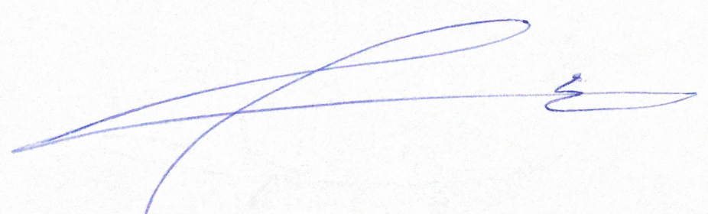 | Signature: | Signature:
Date of Issuing the report:

