REPORT RD0
RISK DEFINITION
TECHNICAL RISK ANALYSIS

REFERENCE: 75075 |  |  | TIS AGENCY: CPV ARABIA
TECHNICAL/S RESPONSIBLE/S:

DESIGN: Mohamed Aboelmakarem

SITE INSPECTIONS: Ahmed Mansour (CIVIL ENGINEERING)

REVISION:  Draft | CONTACT:  Mahmoud Elmasry.
DATE OF ISSUE:  09-Sep-2024 | FAX: | PHONE: 00966553304612 | EMAIL: mmasry@cpvarabia.com
TITLE I

PRINCIPAL/OWNER: ﻣﺆﺳﺴﺔ ﺳﻠﻄﺎﻥ ﺣﻤﻴﺪ ﺍﻟﻤﻄﻴﺮﻱ ﻟﻠﻤﻘﺎﻭﻻﺕ ﺍﻟﻌﺎﻣﺔ

PROPOSER (IF DIFFERENT): ﻣﺆﺳﺴﺔ ﺩﻳﺎﺭ ﻏﻨﻰ ﻟﻠﻤﻘﺎﻭﻻﺕ ﺍﻟﻌﺎﻣﺔ.

PROJECT TITLE: 1 ﻣﺸﺮﻭﻉ ﺭﻗﻢ

ADDRESS: 817 ﻣﺪﻳﻨﺔ ﺍﻟﺪﻣﺎﻡ - ﺣﻲ ﺿﺎﺣﻴﺔ ﺍﻟﻤﻠﻚ ﻓﻬﺪ ﻗﻄﻌﻪ ﺭﻗﻢ.

PROPOSED USE/OCCUPATION: المباني السكنية.

NUMBER OF BUILDINGS: 2

SCOPE OF MISSION: DESIGN
DESIGN + SITE INSPECTIONS
- Date of TIS involvement: 09-Sep-2024
- Inspections from the commencement of Works YES NO
- Missions:

S W.1 E
W.2 Q

W.3 X, specify:
S: Solidity and stability, including the envelope elements
W.x: Waterproofing (1- Roofs, 2- Façades, 3-Basements)
E: Existing structures
Q: Works already started
X: Other
The TIS controls, inspections and checks marked with an X above are based on as analysis of the project, according to the requirements of the demander.

PARTIES INVOLVED
(Full name + Address)

DESIGN:
- ARCHITECT: ﺷﺮﻛﺔ ﻋﻔﺎﺭﺍ ﻟﻼﺳﺘﺸﺎﺭﺍﺕ ﺍﻟﻬﻨﺪﺳﻴﻪ
- STRUCTURAL DESIGNER: ﺷﺮﻛﺔ ﻋﻔﺎﺭﺍ ﻟﻼﺳﺘﺸﺎﺭﺍﺕ ﺍﻟﻬﻨﺪﺳﻴﻪ
- SOIL REPORT: مختبر مجسات لفحص التربة والمواد والخرسانة

CONSTRUCTION:
- MAIN CONTRACTOR: ﻣﺆﺳﺴﺔ ﺩﻳﺎﺭ ﻏﻨﻰ ﻟﻠﻤﻘﺎﻭﻻﺕ ﺍﻟﻌﺎﻣﺔ
- SUBCONTRACTORS:
- PROJECT SUPERVISOR: ﺷﺮﻛﺔ ﻋﻔﺎﺭﺍ ﻟﻼﺳﺘﺸﺎﺭﺍﺕ ﺍﻟﻬﻨﺪﺳﻴﻪ
- QUALITY TESTING FIRMS:
- OTHER (SPECIFY):
COMMENTS ON REFERENCES OF ARCHITECTS, ENGINEERING CONSULTANTS AND CONTRACTORS OF THE OPERATION, PURPOSE OF THE INSPECTION, IF ANY: NO REFERENCES AVAILABLE

DOCUMENTS USED IN THIS REPORT

- STRUCTURAL DRAWINGS.
- ARCHITECTURAL DRAWINGS.
- BILLS OF QUANTITY.
- SOIL INVESTIGATION REPORT.
- PROPOSAL FORM FOR INHERENT DEFECT INSURANCE.
Is there any other document or information missing which is needed for the completion of this report? YES NO
If YES, please specify:
- Construction schedule- Type of steel reinforcement used for foundation, Cast in situ slabs, has not been mentioned in the structure plans.- Ground slope %- Quality assurance procedures- Method statement

CODE TABLE
NATURE OF WORKS | SOIL RISKS | STRUCTURE TYPE | SPECIFICATIONS
CODE N°1: CONSTRUCTION TYPE  A  DETACHED OR SEMI-DETACHED  HOUSES UP TO GF+2 AND B-1  B  TERRACED HOUSES UP TO GF+3 AND B-1  C1  RESIDENTIAL BUILDINGS FROM  GF+4 TO GF+14 AND UP TO B-2  C2  RESIDENTIAL BUILDINGS FROM  GF+15 AND/OR FROM B-3  D1  OFFICES, HOTELS, SCHOOLS  D2  HOSPITALS, CLINICS  D3  COMMERCIAL BUILDINGS, RESTAURANTS, SHOPPING MALLS  E1  OTHER  PUBLIC BUILDINGS: THEATERS, RELIGIOUS  BUILDINGS, STATIONS  E2  STADES  F1  COMMON INDUSTRIAL  BUILDINGS, FACTORIES  F2  LOGISTIC PLATFORMS  G1  RESERVOIRS  G2  SPECIAL INDUSTRIAL  BUILDINGS, SMOKESTACKS,  TANKS, RETAINING WALLS, ETC  H  BRIDGES, FOOTBRIDGES,  JUNCTIONS AND OTHER WORKS | CODE N°2: SLOPE  0 1 2 3 4  <5% 5 to 10% 10% to 20% 20 to 30% >30%  CODE N°3: GROUND WATER AND AGRESSIVENESS  0 no water table  3 works below water table  4 works above water table  N non-aggressive water or soil  Y aggressive water or soil  CODE N°4: FOUNDATIONS  A footings  B raft  final settlement 0 1 2 3 4  <2 cm 2 to 5 cm >5 cm  C piles or contiguous piles wall  D friction piles  E diaphragm wall  F shafts  depth 0 1 2 3 4  0 to 3 m 3 to 10 m 10 to 25 m 25 to 30 m >30 m  Z Other foundation type  CODE N°5: GROUND SPECIFIC RISKS  O no ground specific risks  P underground quarries, sinkholes, karsts  Q mining ground  R Anchored earth retaining structure. (h > 3 meters)  S underpinning, basement construction  T ground consolidation (grouting compaction; dynamic compaction/vibration)  U hazardous storage, concentrated surcharge loads, embankment  V Compressive layer  W founding on fill  X other ground risk  Y at least 2 ground specific risk  Z new foundation type | CODE N°6: STRUCTURE  A  VERTICAL STRUCTURES MASONRY  B  REINFORCED CONCRETE CAST IN-SITU  C  PRECAST REINFORCED CONCRETE - PREFABRICATED IN FACTORY RESIDENTIAL BUILDINGS FROM  GF+4 TO GF+14 AND UP TO B-2  D  PRECAST REINFORCED CONCRETE - ON SITE  E  PRESTRESSED CONCRETE EXCL. POST-TENSIONED CONCRETE  F  STEEL WORKS - SITE ASSEMBLY  G  PRE-ASSEMBLED STEEL WORKS  H  ON SITE WELDING  I  TIMBER STRUCTURE  X  TRADITIONAL COMPOSITE STRUCTURE  Y  WORKS ON EXISTING STRUCTURES - BASEMENT CONSTRUCTION - NEW FLOORS  Z  NEW STRUCTURAL SYSTEMS INCL. POST-TENSIONING | CODE N°7: FACADE  A concrete wall or masonry  B sandwich or timber panels  C curtain walls – steel frame glazing  D curtain walls – glazing fixed with glue  E curtain walls – glazing fixed bolts  F breathable glazed curtain wall  G cable curtain wall  Z other type  CODE N°8: HEIGHT  0 1 2 3 4  Height - Ho <25m 25 to 35m 35 to 60m 60 to 100m >100m  Maximum Headroom - Hp <8m 8 to 15m 15 to 35 m 35 to 50m >50m  CODE N°9: DEPTH  1 2 3 4  Depth <5m 5 to 10m 10 to 15m >15m  CODE N°10: SPANS  0 1 2 3 4  Spans <15m 15 to 20m 20 to 30m 30 to 40m >40m  Spans (timber) <10m >10m  CODE N°11: CANTILEVER  0 1 2 3 4  Cantilever None 0 to 2m 2 to 5m 5 to 10m >10m  CODE N°12: SITE EXPOSED  0 1  Distance to the sea >5km <5km  CODE N°13: WND SENSITIVITY  0 Concrete or masonry structure  1 Steel, timber or composite structure  CODE N°14: WATERPROOFING OF ROOFS  A1 pitched roof - tiles  A2 pitched roof - steel roof-deck  A3 pitched roof - sandwich panels  B1 flat roof-non practicable normal waterproofing  B2 flat roof-non practicable inverted waterproofing  B3 flat roof-practicable normal waterproofing  B4 flat roof-practicable inverted waterproofing  CODE N°15: WATERPROOFING OF BASEMENT  A External treatment (PVC, bitumen based, polyurethane membranes)  B Crystallization technology by concrete additive  C Other  Z No basement

PROJECT OVERALL VIEW
CODE | 1 | 2 | 3 | 4 | 5 | 6 | 7 | 8 | 9 | 10 | 11 | 12 | 13 | 14 | 15
BUILD.1 | B | 0 | 0 Y | A B 1 | W | F B | A | 0 0 | 1 | 0 | 1 | 0 | 0 1 | A2 B4 | Z
Concerning the code table above, please complete one line per building/structure and explain each code below. PLEASE EXPLAIN IF SEVERAL CODES INDICATED IN THE SAME CASE.
CODE 1: The project is Residential. It consists of 3 floors
CODE 2: No value has been indicated in the geotechnical report, so it is estimated that due to the geology of the area it is less than 5%.
CODE 3: Ground water level was not detected in the boreholes. Aggressive due to water or soil ( Chloride in Soil= 0.7 % , Sulfate in Soil= 0.9 % ) and the actual concrete compressive strength is 25 MPa.
CODE 4: The foundation type: Isolated Footings,Raft Foundation,and the settlement value:25 mm
CODE 5: Founding on replacement soil.
CODE 6: steel works, in columns, reinforced concrete cast in-situ, in foundation, reinforced concrete cast in-situ, steel works, in ground floor slab, steel works, reinforced concrete cast in-situ, in last floor slabs
CODE 7: Concrete wall or masonry
CODE 8: The total height is:20 m and the maximum headroom (Hp):4m
CODE 9: Level of Foundation from street level: -1.5 m , -2.5 m
CODE 10: The maximum span is, approximately: 9 m
CODE 11: Maximum cantilever of the balconies: 2 m
CODE 12: The distance to the sea > 5 km
CODE 13: Concrete or masonry structure and Steel, timber, or composite structure
CODE 14: The roof waterproofing is not mentioned and the common case is pitched roof - steel roof-deck, flat roof-practicable inverted waterproofing
CODE 15: No basement

Summary description of the work, nature of the foundations and of the structure, specify the particularities (for example the presence of a ground water level and its position in relation to the last basement, the presence of basements or existing buildings along an excavation).
The project is Residential. It consists of 3 floors , Total Building height = 20 m
The project consists of reinforced concrete beams and columns, founded on Isolated Footings,Raft Foundation,The floor slab of all slabs, including roof slab, are 32cm thick reinforced concrete hollow block slabs with beams, and 15cm thick reinforced concrete solid slabs

DRAWINGS

Please annex the following drawings, if available:

LOCATION
GENERAL DRAWING
PLANS
SECTIONS
FACADES & ROOFS & TERRACES
FOUNDATIONS
OTHER, PLEASE SPECIFY:

THESE DRAWINGS ARE ATTACHED IN ANNEX I. DRAWINGS.

PROVISIONAL TOTAL COST OF WORKS

Are Architect and Engineering Consultants fees included in the cost of the works: | YES NO
- Total cost of the works: 735,090.00 SAR
- Structural works: 270,090.00 SAR
- Envelope: 200,000.00 SAR
- Non-structural works: 100,000.00 SAR
- Equipment, fixtures, and fittings: 50,000.00 SAR
- External works: 50,000.00 SAR
- Design and professional fees: 15,000.00 SAR
- Taxes: 50,000.00 SAR
Is there any special equipment (industrial machinery used in the manufacture of products or services) included in the cost other than those usually used in common constructions? | YES NO
If so, please specify: Nature:
Cost:

DATES AND CONSTRUCTION TIMES

Expected duration of work (months): 2months
Date of commencement of construction: 21-Mar-2022
Date of the first on-site visit of the Inspection Agency: 05-Apr-2022
Expected date of practical completion: 09-Jan-2022

TITLE II
SITE DESCRIPTION
Is the building likely to be flooded (river, lake or sea, ground water level)? YES NO
Maximal level of the ground water level to ground floor and to the last basement:
- Ground water level was not detected in the boreholes
- Ground floor level is +0.45 m.
- No Basement

Is there a system to prevent the effect of the water under-pressure? NA YES NO
If YES, please specify:
Is the building located in a seismic area? Region 5 YES NO
If YES, could you specify the level of protection? (Specify: statutory or contractual?): statutory
Acceleration value: PGA=Not Mentioned .
Indicate in % the ground slope: No value has been indicated in the geotechnical report, so it is estimated that due to the geology of the area it is less than 5%..
If >15%, was the landslide risk evaluated in the Geotechnical Report and/or the design? NA YES NO
If NO, please make a reserve in conclusions.
Is the building located in a cyclone area? YES NO
Wind speed considered in the calculations (km/h): approximately 152 km/h
Is snow load applicable? YES NO
If so, snow load value:
Is the site located in a hostile environment (<5 km sea, soil, and underground water)? YES NO
If YES, specify the nature and the protection provided:
The nature:
Ground water level was not detected in the boreholes. Aggressive due to water or soil ( Chloride in Soil= 0.7 % , Sulfate in Soil= 0.9 % ) and the actual concrete compressive strength is 25 MPa.

The protection provided:
- Use of (SRC) sulfate resisting cement type 5, Minimum Cement Content 350 kg/m3, the maximum water-cement ratio in the concrete mix is 0.50, and the minimum reinforcement concrete cover is 75 mm according to the geotechnical report. - Foundation elements should be coated below the ground surface with Bitumen.

GEOLOGY - TOPOGRAPHY – FOUNDATIONS

Has a geotechnical engineer been involved in the design? YES NO
Is there a geotechnical report? YES NO
(If YES, please indicate the scope, number, and type of geotechnical tests and describe the layers including thickness).
Number of boreholes: 3
- Borehole 1: BH-1, depth of: 4m- Borehole 2: BH-2, depth of: 5m- Borehole 3: BH-3, depth of: 6m
Type of tests and trials:
- Chemical Analysis
Description of the layers including thickness:
(0.00 m -2.00 m) Fill material
(2.00 m - 4.00 m) Silty clay
(4.00 m - 10.00 m) Poorly graded sand with clay

Are the adopted foundations founded on natural soil? YES NO
Depth of excavation: -2.5 m from the street level.
Depth of soil supporting foundations: -1.5 m and -2.5 m from the street level.
Nature of soil supporting foundations: well graded sand with silt, yellowish brown, medium dense, dry.
All earthworks to be performed shall be compliant with the recommendations indicated in the geotechnical report.
Please describe the foundations (level of foundation, bearing capacity, bearing pressure):
- Foundation type: Isolated Footings,Raft Foundation,
- Bearing Capacity: 2 kg/cm².
Are the conclusions of the Geotechnical Report relevant? YES NO
If NOT, please explain the reason:
ABC
Is the ultimate settlement indicated in the geotechnical report? YES NO
Please indicate the value: 25 mm.
Is the foundation system in line with the soil report? YES NO
If NOT, please precise the differences and the reason: AB
Has the RD1 report been filled in? YES NO
If YES, please mark below the reason:
Presence of back fill or compressible or expansible layers being used as foundations for the works
Presence of piles, diaphragm walls or shafts superior to 3 m deep
Presence of ground slopes exceeding 30% or cliffs sides
Risk of ground sliding after soils excavation
Are additional surveys needed? YES NO
If YES, please precise:
- According to 303 Structural - Soil and Foundations Standard, in table 2.1, the minimum depth of one third of the boreholes for this case is 9 m (measured from level of foundation bottom), and this does not comply.- According to 303 Structural - Soil and Foundations Standard, in table 2.1, the minimum depth of two third of the boreholes for this case is 6 m (measured from level of foundation bottom). This does not comply. - Shear Test Parameters- Soil/Rock Quality Degree Test

TITLE III
The items below must be descripted briefly but detailed enough to include any relevant information.
The used technologies must be specified where is possible: traditional construction, prefabricated structural elements, steel/concrete mixed structures, pre-tensioned (factory or site), welding (factory or site), etc
It is a traditional system.
Please indicate if innovative materials or technics are used which means (completion of RD2 report mandatory).
No innovative materials or technics are used.
VERTICAL STRUCTURES
Full description of the adopted model.

Are there non-vertical loads/transfer structures? YES NO

VERTICAL ELEMENTS (COLUMNS, BEARING WALLS)
Nature (reinforced or prestressed concrete, metal, timber...):
- Steel ColumnsType of steel section:Steel section details are attached in Annex 1
HORIZONTAL STRUCTURAL ELEMENTS
FOUNDATIONS
Nature (concrete, masonry, ..): Cast in situ.
- Use of (SRC) sulfate resisting cement type 5, Minimum Cement Content 350 kg/m3, the maximum water-cement ratio in the concrete mix is 0.50, and the minimum reinforcement concrete cover is 75 mm according to the geotechnical report. - Foundation elements should be coated below the ground surface with Bitumen.
Footings
Fc` : 25 Mpa
Fy: Not Mentioned
FLOOR SLABS
Nature (reinforced or prestressed concrete, metal, timber...):
- Cast is situ slabs:Fc= Not MentionedFy= Not MentionedMaximum span for beams (m): 5 mMaximum span for slabs (m): 8 m- Maximum cantilever of the balconies (m):2 m- Steel Slabs SystemType of steel section:Steel section details are attached in Annex1Maximum span for beams (m): 6 mMaximum span for slabs (m): 9 m- Maximum cantilever of the balconies (m):2 m
ROOF STRUCTURAL ELEMENTS
Please note if those are: FLAT PITCHED
If flat, similar to floor slab? YES NO
If NO indicate modifications:
If pitched, please note its main characteristics:

HEAVY FACADES
Type, total thickness, rendering, cladding...
(Specify load-bearing facades or not, precast, or not.)
Façade details:
Concrete wall or masonry
LIGHT-WEIGHT FACADES
Not Applicable
Frame (aluminum, steel, timber or other):
Filling (glass, composite wall, in this case, specify the constitution):
Total surface of each type of façade:
Possibility to replace the façade elements easily: YES NO
HORIZONTAL STABILITY
Traditional structural elements (frame, inner walls, bracings...)? YES NO
If not: fill in the complementary report RD2
Traditional structural elements are reinforced concrete frames.
BASEMENT WATERPROOFING
The project doesn´t include basement
Presence of water (water flow, water table)? YES NO

If YES: solution chosen (waterproofness, drainage, and shaft lining...)
waterproofing system:
FACADE WATERPROOFING

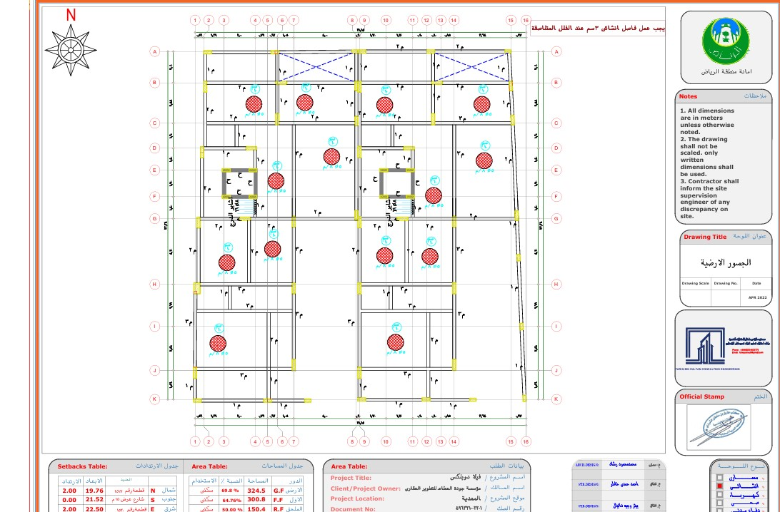

ROOF WATERPROOFING
Roof details:

GROUND SLAB
Is the ground slab suspended? YES NO
If NOT, is the ground slab bearing on backfill? YES NO
Maximum thickness of backfill: 1.75 m from the bottom of the foundation to the bottom of the slab on grade.
Loads:
Spread: YES NO Value: not informed
Concentrating/rolling: YES NO Value:
Other: YES NO Value:

TITLE IV
IDENTIFIED AGGRAVATING RISKS AND ADDITIONAL INFORMATION:
(For example, large span beams or slabs, foundation for heavy and/or vibrating machinery, etc.)
It is necessary to submit the documents indicated in title I, referring to the documents used in this report.
Design (RD5):
- AB B
Inspection (RD5):
- The Foundations are supported on backfill layers more than 30cm.- The length of the building is greater than 45 m.
Technical reservations:
- Technical reservation: The structural model of this project is provided, please check it, and add your comments and recommendations provided, please check it, and add your comments and recommendations- Technical reservation: The ground slab is supported on a backfill of more than 30cm. The contractor must execute the filling following a procedure approved by a geotechnical firm, which will oversee the monitoring too (for instance by making regular compaction tests). The TIS must be informed about the compaction procedure and check the process/results (The inspection team will check at the site).
Notes:
- The warranty of facades insulation must be provided by the client before issuing (RD3).- According to 303 Structural - Soil and Foundations Standard, in table 2.1, the minimum depth of one third of the boreholes for this case is 9 m (measured from level of foundation bottom), and this does not comply.- According to 303 Structural - Soil and Foundations Standard, in table 2.1, the minimum depth of two third of the boreholes for this case is 6 m (measured from level of foundation bottom). This does not comply. - The existence of raft and another footing type working together in the same building was detected, it is probable that the raft will have a higher settlement than the footings, It is necessary to analyze in greater detail the differential settlements between both types of foundations.
Aggravating risks:
- It was not specified how the connection between the masonry of the facade and the concrete structure is made.- No specification has been found regarding insulation and waterproofing of the joints between different types of facades.- Type of steel reinforcement used for foundation, Cast in situ slabs, has not been mentioned in the structure plans.- There are no details about lintels (dimension and reinforcement).- The soil study doesn't present shear test parameters.- The soil study doesn't present soil/rock quality degree tests.

TECHNICAL STANDARDS USED IN THE PROJECT:
- 301 Structural – Loading and Forces.
- 302 Structural – Testing and Inspection.
- 303 Structural – Soil and Foundations.
- 304 Structural – Concrete Structures.
- 305 Structural – Masonry Structures.
- 306 Structural – Steel Structures.
Are they relevant? YES NO
If NOT, please specify why:

TITLE V
CONCLUSIONS
Additional reports needed to estimate the risks and issuing date:
RD1 Special Foundation Report – Expected date:
RD2 Innovative materials/procedures report – Expected date:
RD3 Waterproofing assessment report (Waterproofing Certificate Approval) – Expected date: 09-Jan-2023
RD5 Works interruption report – Expected date: It will be issued to highlight major deviation noted on site during inspection or failure to submit the required documents
RD6 Final risk assessment report (Certificate of Approval) – Expected date: 10-Jan-2022
RISK TECHNICAL ASSESSMENT
(Risk assessment based on the checked documents. Please specify topics requiring special focus).

Within the scope of its mission, the CPV, based on the technical documentation received from the project and after its general preliminary analysis and reflected in this report, it is considered that the TECHNICAL RISK IS AGGRAVATED However, If the questions raised in this report are clarified, some of the aggravating situations can be reduced to a normal risk situation.
A list of AGGRAVATING RISKS is included in title IV of this document.
TI605-75075
TI302-75075
technical reserves were opened:

Does the risk require the involvement of any TIS headquarter expert? YES NO
If YES, specify the reason:

Minimum number of site visits: 5
Of which:
-Foundations visits: 01
-Structure visits: 02
-Waterproofing (if relevant): 01
-Final inspection: 01
Riyadh, 09-Sep-2024

THE TECHNICIAN/S IN CHARGE OF THE CONTROL



ENG. Mohamed Aboelmakarem
Civil engineer

Project Analysis Department Manager

${B4772}
ENG. MAHMOUD ELMASRY
Civil engineer

Quality Control Manager

${B4771}

ENG. Alaa Abdulkareem
Civil engineer

ANNEX I. DRAWINGS.

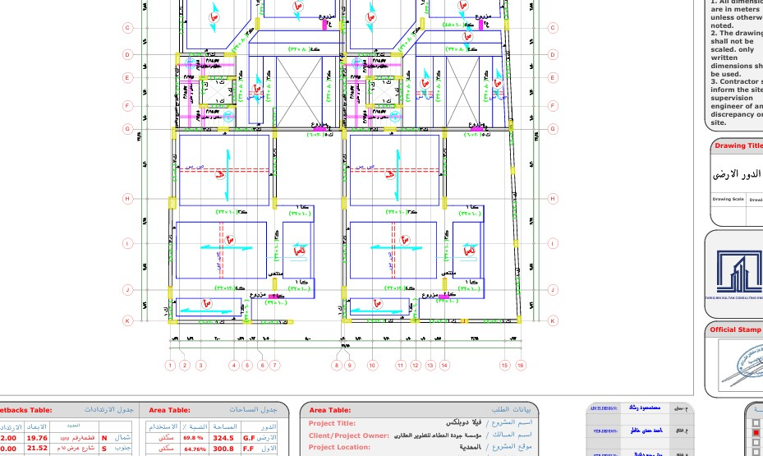

LOCATION

